

ADDENDUM #2
RFP #26-0041
EMPLOYEE ANCILLARY BENEFITS – COBRA ADMINISTRATION

May 22, 2026

The following is to ensure that vendors have complete information prior to submitting a Request for Proposal. Here are some clarifications regarding the Employee Ancillary Benefits – COBRA Administration. Questions and/or statements of clarification are in bold font and answers to specific questions are italicized.

- Please provide the Monthly Admin Fee the county pays for COBRA Administration.

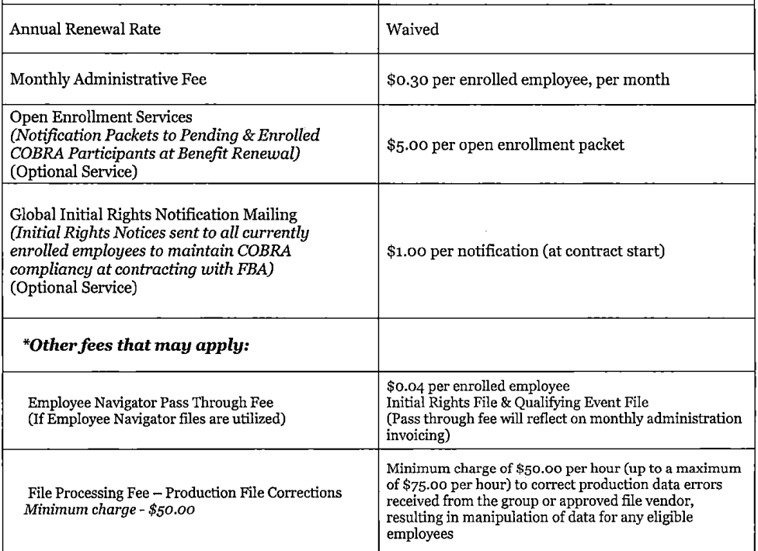

- Please provide any additional fees the county pays for COBRA, such as notices, open enrollment kits, etc.

- If the county requires a rate guarantee, please provide the number of years.

Yes, 3-year term with opportunity for 2 additional 1-year contracts to follow.

- Please provide the name of the COBRA vendor and number of years the vendor has provided COBRA Administration for the county.

FBA; 5 years.

- Are there any other forms, other than the Response Form, required to be signed and submitted regarding the RFP Proposal Response? I was not able to identify any other forms from the RFP Document.

No.

- The RFP Document mentions questionnaires required with the response. Are the questionnaires separate from the RFP Document or are the questions included within the RFP Document?

No, just the initially released RFP.

- Can you identify the current third-party COBRA vendor providing COBRA administration services, along with the current pricing?

FBA; 5 years.

- What is the current number of COBRA continuants?

168 Retirees and 140 COBRA.

- How does the county currently pay for COBRA, per notice or per insured?

- Can you disclose current COBRA pricing?

- How many COBRA initial notices were sent out in the last twelve months? How many Qualifying Event notices were sent out in the last twelve months?

- Initial notices/new hire notices = 456.
- Total qualifying event notices in the past 12 months = 436.

- What is the county’s current COBRA activity - Roughly, how many terms in the last twelve months? How many new hires in the last twelve months?

- Terms in the last twelve = 460
- New hires in the last twelve months = 421

- The RFP references a questionnaire document that does not appear to be included with the current RFP. Will the county be releasing an additional questionnaire?

No, just the initially released RFP.

- Is the COBRA administrator expected to pay carriers directly? Or can COBRA premiums be remitted to the county on a monthly basis?

Premiums are remitted to Sedgwick County and Sedgwick County pays the carriers. Currently, the county receives a monthly check from FBA for the 100% of premiums. Then Sedgwick County pays the monthly bills (carriers) which include retirees/cobra.

- How many HR locations are responsible for COBRA Administration?

One.

- What is the estimated number of administrative users or HR contacts?

Two.

- How many benefit eligible employees does the county employ?

2724.

- How many insured employees?

2724.

- What was the number of insured employees in 1/1/25 & 1/1/24?

2024 = 2,777 and 2025 = 2,780.

- How many COBRA active participants are there currently? Please exclude beneficiaries.

168 Retirees and 140 COBRA. We are unable to exclude beneficiaries because once a beneficiary has a dependent event, they show as a QB (they look like they were an employee even though they are a dependent).

- What is the population of COBRA eligible former employees who have not elected COBRA continuation but are still within their election period? Please exclude beneficiaries.

Currently there are 77 people that went over in the past 60 days.

- What is the average number of COBRA qualifying events per month?

50 per month over the last 12 months.

- What is the average number of new hires per month?

100 over the last 12 months.

- What is the average number of terminations per month?

Average over the past year is 35-36 terminations per month.

- What is the average COBRA Medical Premium?

Premier $750 PPO: $805 EE, $1,771 EE+SP, $1,449 EE+CH, $2,414 EE+FAM
Base PPO $1250: $766 EE, $1,686 EE+SP, $1,380 EE+CH, $2,299 EE+FAM
HDHP: $706 EE, $1,552 EE+SP, $1,270 EE+CH, $2,117 EE+FAM

- How many COBRA qualified plans are there within the scope of the RFP? Please list their renewal dates.

Medical/Rx – 1/1
Dental – 1/1
Vision – 1/1
FSA – 1/1

- How many insurance carriers provide plans to the county?

There are four COBRA-eligible benefits offered by the county.

- Who is the current HRIS/Benefits administrator?

Success Factors.

- Please provide the current pricing for the requested RFP services.

- Please describe how the incumbent administrator supports the county’s annual open enrollment?

The county would like their COBRA administrator to support open enrollment activities. Please confirm how you support clients through the open enrollment process.

- Please refer to the scope of work, section “Reporting & Analytics “. What type of custom reporting is the county looking for? Please give a use case.

Active membership report separated by COBRA vs. retiree. ACA reporting supplemental information.

- Please confirm whether the county currently transmits new hire and qualifying event information through electronic files, and if so, what vendor and/or HRIS systems are currently utilized.

Success Factor (and SFTP)

- Please clarify whether retirees remain on coverage indefinitely until age 65, or whether there are additional eligibility termination rules the awarded vendor will be responsible for administering.

Covered to age 65. No additional eligibility termination rules.

- Will the awarded vendor be expected to provide open enrollment support and annual retiree rate communication materials for both the COBRA the retiree population?

Yes.

- Please confirm whether the county currently transmits new hire and qualifying event information through electronic files, and if so, what vendor and/or HRIS systems are currently utilized.

Yes, Success Factors.

- Please clarify whether retirees remain on coverage indefinitely until age 65, or whether there are additional eligibility termination rules the awarded vendor will be responsible for administering.

Retirees are covered to age 65 and then offered COBRA.

- Will the awarded vendor be expected to provide open enrollment support and annual retiree rate communication materials for both the COBRA the retiree population?

The county would like their COBRA administrator to support open enrollment activities. Please confirm how you support clients through the open enrollment process.

Firms interested in submitting a Request for Proposal, must respond with complete information and deliver on or before 1:45 pm CDT, June 2, 2026. Late responses will not be accepted and will not receive consideration for final award.

“PLEASE ACKNOWLEDGE RECEIPT OF THIS ADDENDUM ON THE RFP RESPONSE PAGE.”

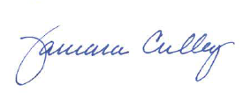

Tammy Culley
Purchasing Agent

TC/ch

