Sedgwick County Fire Department
Period Rate (Utilization Rate)  The total number of Files, Serviced, or Activities divided by the weighted employee population for the reporting period. |  | Projected Annual Rate (Annualized Utilization Rate) This is the "projected" yearly File, Serviced, or Activities utilization rate.
Period Rate (Count): |  |  | 5.44%
Projected Annual Rate (Count): |  |  | 5.44%
New/Ongoing Files Summary
Total New Files | 4

January 01, 2024 - December 31, 2024 on New and Open Files

UTILIZATION BY THE NUMBERS
EAP Summary | Count |  | % | Serviced |  | % Activities % Hours
EAP Files |  | 5 | 62.5% |  | 7 | 07.6% | 27 |  | 84.4% | 17.42
Organizational Service/CISD |  | 3 | 37.5% |  | 85 | 92.4% | 5 |  | 15.6% | 8
Supervisor Referral |  | 0 | 00.0% |  | 0 | 00.0% | 0 |  | 00.0% | 0
SAP Files |  | 0 | 00.0% |  | 0 | 00.0% | 0 |  | 00.0% | 0
Total |  | 8 | 100% |  | 92 | 100% | 32 |  | 100% | 25.42
Count  Includes the total number of files, organizational services, information calls etc. that have an open/service date that falls between (and includes) the reporting period date range. | Serviced  The total number of service users (attendees) within files or organizational services that have an open/service date that falls between (and includes) the reporting period date range. |  |  | Activities  The total activities (contacts) from files, organizational services, information calls etc. that have an activity date that falls between (and includes) the reporting period date range. |  |  |  | Hours  The total duration from all activities that have an activity date that falls between (and includes) the reporting period date range.
EAP Utilization Rates |  |  |  |  |  | Based on a weighted population of: 147

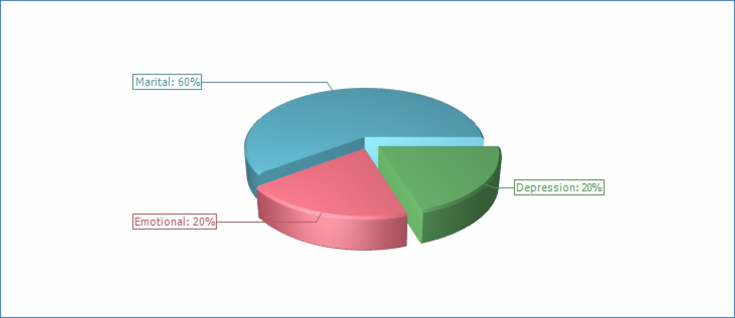
Primary Presenting Problem

Primary Presenting Problem | 1/2024 - 12/2024
Primary Presenting Problem | # | %
Depression | 1 | 20.00%
Emotional | 1 | 20.00%
Marital | 3 | 60.00%
Total | 5 | 100%

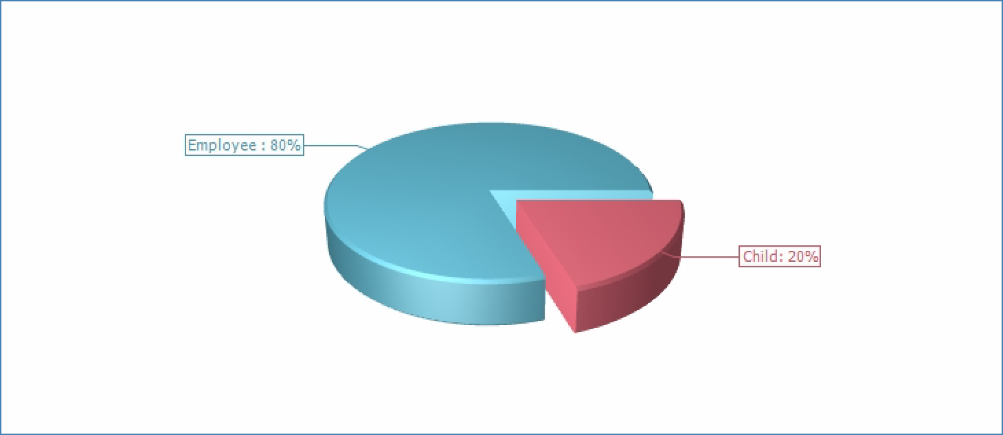
Client Type

Client Type | 1/2024 - 12/2024
Client Type | # | %
Child | 1 | 20.00%
Employee | 4 | 80.00%
Total | 5 | 100%

