Sedgwick County
Period Rate (Utilization Rate)  The total number of Files, Serviced, or Activities divided by the weighted employee population for the reporting period. |  | Projected Annual Rate (Annualized Utilization Rate) This is the "projected" yearly File, Serviced, or Activities utilization rate.
Period Rate (Count): |  |  | 12.51%
Projected Annual Rate (Count): |  |  | 12.51%
New/Ongoing Files Summary
Total New Files | 318

January 01, 2024 - December 31, 2024 on New and Open Files

UTILIZATION BY THE NUMBERS
EAP Summary | Count |  | % | Serviced |  | % Activities % Hours
EAP Files |  | 347 | 86.8% |  | 411 | 72.5% | 1753 |  | 93.8% | 1269.57
Organizational Service/CISD |  | 35 | 08.8% |  | 138 | 24.3% | 37 |  | 02.0% | 50.75
Supervisor Referral |  | 18 | 04.5% |  | 18 | 03.2% | 78 |  | 04.2% | 43.27
SAP Files |  | 0 | 00.0% |  | 0 | 00.0% | 0 |  | 00.0% | 0
Total |  | 400 | 100% |  | 567 | 100% | 1868 |  | 100% | 1363.58
Count  Includes the total number of files, organizational services, information calls etc. that have an open/service date that falls between (and includes) the reporting period date range. | Serviced  The total number of service users (attendees) within files or organizational services that have an open/service date that falls between (and includes) the reporting period date range. |  |  | Activities  The total activities (contacts) from files, organizational services, information calls etc. that have an activity date that falls between (and includes) the reporting period date range. |  |  |  | Hours  The total duration from all activities that have an activity date that falls between (and includes) the reporting period date range.
EAP Utilization Rates |  |  |  |  |  | Based on a weighted population of: 3182

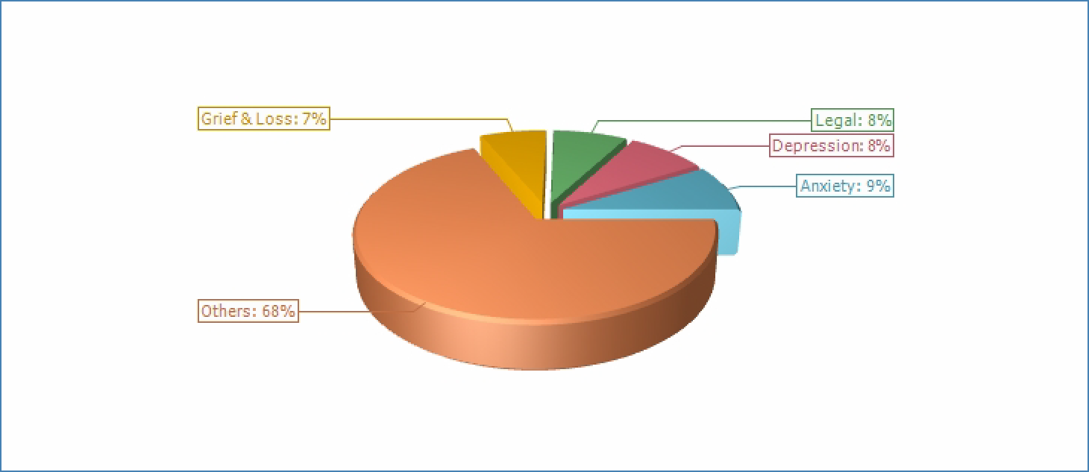
Primary Presenting Problem

Primary Presenting Problem | 1/2024 - 12/2024
Primary Presenting Problem | # | %
Abuse/Trauma | 1 | 0.29%
Addiction Issues | 7 | 2.01%
ADHD | 2 | 0.57%
Alcohol | 2 | 0.57%
Anxiety | 30 | 8.60%
Behavioral Problems | 5 | 1.43%
Bipolar | 1 | 0.29%
Burnout | 2 | 0.57%
Check in call | 1 | 0.29%
Coaching | 2 | 0.57%
Communication | 1 | 0.29%
Depression | 29 | 8.31%
Divorce | 5 | 1.43%
Elder Care | 1 | 0.29%
Emotional | 14 | 4.01%
Family/Relationship | 22 | 6.30%
Fear | 1 | 0.29%
Financial | 8 | 2.29%
Gender Identity | 1 | 0.29%
Grief & Loss | 24 | 6.88%
Legal | 27 | 7.74%

Primary Presenting Problem
 | 1/2024 - 12/2024
 | # | %
Life Changes | 18 | 5.16%
Mandatory | 6 | 1.72%
Marital | 23 | 6.59%
Medical | 1 | 0.29%
Mental Health | 21 | 6.02%
Parenting | 3 | 0.86%
Postpartum Depression | 1 | 0.29%
PTSD | 3 | 0.86%
Relationship | 10 | 2.87%
School | 2 | 0.57%
Self-Harm | 2 | 0.57%
Stress Management | 22 | 6.30%
Suicidal | 2 | 0.57%
Trauma | 8 | 2.29%
Wellness | 1 | 0.29%
Work/Life Issues | 22 | 6.30%
Workplace Related | 18 | 5.16%
Total | 349 | 100%

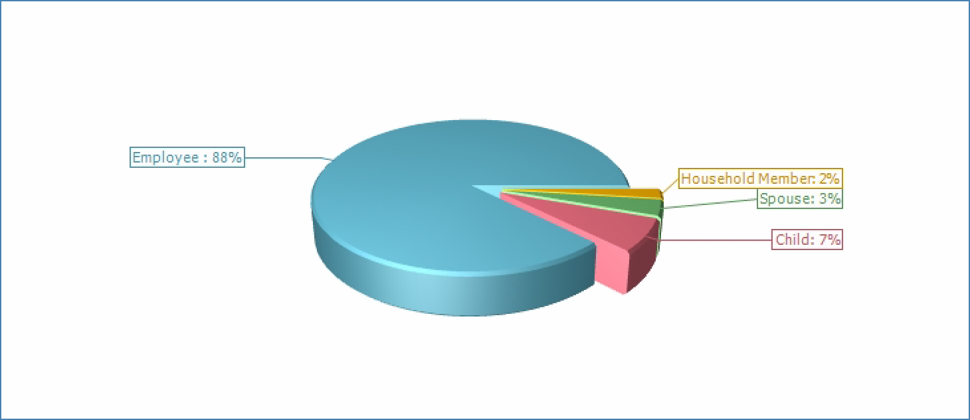
Client Type

Client Type | 1/2024 - 12/2024
Client Type | # | %
Child | 25 | 6.91%
Employee | 318 | 87.85%
Household Member | 7 | 1.93%
Spouse | 12 | 3.31%
Total | 362 | 100%

