

ADDENDUM #2
RFP #26-0046
EMPLOYEE ANCILLARY BENEFITS - LIFE, ACCIDENTAL DEATH AND DISMEMBERMENT,
AND DEPENDENT LIFE INSURANCE

May 22, 2026

The following is to ensure that vendors have complete information prior to submitting a Request for Proposal. Here are some clarifications regarding the Life, Accidental Death and Dismemberment, and Dependent Life Insurance. Questions and/or statements of clarification are in bold font and answers to specific questions are italicized.

- Please request complete certificates for the Life, Dental, and Vision plans. We have high level plan information but full certificates are needed to fully understand the plans and the provisions to be quoted.

Attached.

- Group is 2,500 lives. Please request at least 36 months of experience for Basic Life, Optional Life, Dependent Life as well as month-by-month premium, lives, and volume.

Attached, note due to the self-billed nature of this group, AICK does not maintain historical “live count” records. Enrollment and coverage volumes are reported and managed by the employer, and therefore historical tracking of live counts is not retained within AICK’s systems.

The optional life benefit became effective January 1, 2023. Since that time, total premium versus claims experience is as follows:

Premium | Claims | Loss Ratio
$702,905 | $304,993 | 43%

5-year Claims Experience for Term Life/AD&D/Dependent Life:

From | To | Premiums | Claims | Loss Ratio
01/01/2021 | 12/31/2021 | $ 273,533.69 | $ 301,250.00 | 110%
01/01/2022 | 12/31/2022 | $ 283,062.00 | $ 221,250.00 | 78%
01/01/2023 | 12/31/2023 | $ 209,872.74 | $ 260,000.00 | 124%
01/01/2024 | 12/31/2024 | $ 183,452.03 | $ 355,000.00 | 194%
01/01/2025 | 12/31/2025 | $ 165,781.21 | $ 180,000.00 | 109%

- Have there been any plan changes or rate changes in the past 36 months. If so, please describe those changes.

No.

- The RFP is requesting standalone EAP coverage. We don’t offer a standalone EAP product. The LTD UW and I will identify which product is the be included on and will disclose in rate communication and the proposal.

That is acceptable.

- Requested coverages are direct. I don’ t see any mention of commissions and will quote net of commission. Please confirm this is correct.

Correct, please quote net.

- Can the group please provide the following:
- Booklets or summaries that outline requested benefits? Documents provided do not contain necessary information needed to complete a quote.

Attached.

- A census that identifies employees DisFlex STD EP and Duration elections.

Attached.

- Life experience (basic, dependent, supplemental, ADD) for the last 5 years? We require Paid claims, Premium, and historical lives.

See above for claims experience available.

- Claims listing for life (basic, dependent, supplemental, ADD)? We require Gender, DOB, Date of Death/Incurred Date, Claim amount, and Premium waiver claims.

See above for claims experience available

- STD Experience for the last 36 month? We require paid claims, premium, lives, and volume.

Included in worksite addendum.

- STD Open/Closed claims listing for the last 36 months.

Included in worksite addendum. Report is filtered by 2 open STD claims, remove the filter to see all paid claims.

- What commissions is this group looking for? I do not see it specified.

Net.

- A most recent invoice/bill.

The county operates on a self-billed arrangement, and as such, AICK does not issue a standard invoice. Premiums are calculated and remitted based on the employer-reported enrolled volumes. The census provided includes current enrollment levels and coverage amounts by benefit, which serve as the basis for billing.

- A rate history. Please provide the current rates and renewal from MetLife.

The 2027 renewal has not yet been developed, as the renewal process is scheduled to begin in September. Current rates below:

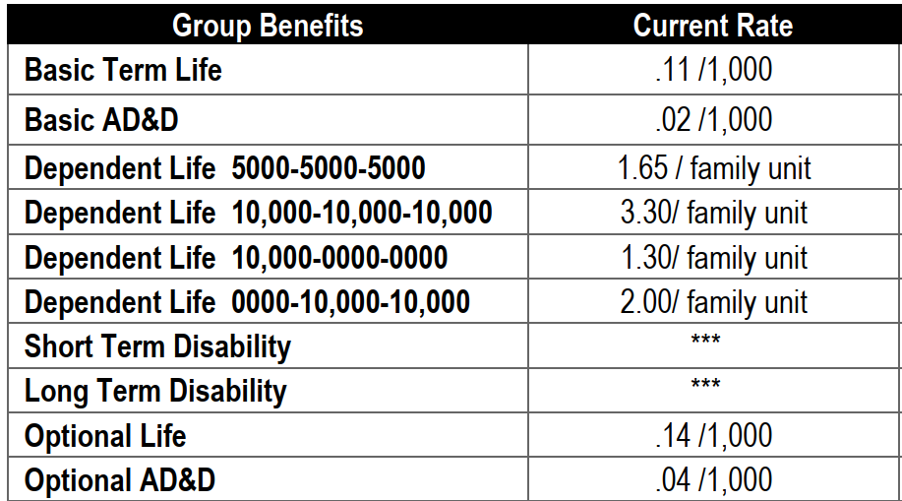

- Please provide a copy of the premium history, claim experience for the last 3-5 years.

See above for claims experience available.

- Our best practice for executing our proposal documents is via electronic signatures, which are legally binding in the United States.

The county can accommodate electronic signatures.

- Will you accept an electronic signature from the appropriate executive at our company in lieu of a manual signature?

The county can accommodate electronic signatures.

- Could you send us your EAP summary?

Included in the EAP addendum.

- With group life insurance, claims history is one of the strongest indicators of future experience. Please provide the following experience data, separately for each line of coverage, for the past three to five years, so that we can determine rates appropriately aligned with the plan’s actual risk. Without claims experience, carriers may tend to use conservative assumptions and not provide you with the best pricing. Experience data is typically shared with group life insurance RFPs.
  - Annual paid premiums
  - Annual paid claims
  - Average annual volume
  - A detailed list of all death and AD&D claims paid

See above for available claims experience.

- Please provide a copy of a recent monthly billing statement or premium remittance statement. This allows us to compare census volumes to reported billing volumes.

The county operates on a self-billed arrangement, and as such, AICK does not issue a standard invoice. Premiums are calculated and remitted based on the employer-reported enrolled volumes. The census provided includes current enrollment levels and coverage amounts by benefit, which serve as the basis for billing.

- Does the Sedgwick County plan include Waiver of Premium? If so, please provide a list of open Waiver of Premium claims including gender, date of birth, date of disability, and amounts of life coverage, for all current disabled insureds.

No.

- Please provide a copy of the current Life and AD&D policy or certificate so that our proposal can match current plan provisions as closely as possible. If this isn’t available, please provide the following:

Attached.

Plan design, including benefits, maximum limits, guaranteed issue limits, etc.

Waiver of premium parameters, including disabled prior to age X, elimination period, termination age, definition of disability

Age reduction schedules

Whether any guaranteed issue opportunities are available at annual enrollment, e.g., if an insured elected $50,000 in optional life when he first became eligible, but increases that to $75,000 for 1/1/2027, will he have to provide evidence of insurability

The additional benefits, a/k/a bells and whistles, included with the AD&D plans, such as air bag, seatbelt, child education benefits

- The RFP states that payment will be remitted following receipt of monthly detailed invoice. Will the life insurance plan be self-administered / self-billed by the County, or will the insurance carrier be responsible for maintaining individual employee records and for generating monthly invoices?

The county is currently self-bill.

- Please provide the current rates and renewal from MetLife.

See above for current rates. Renewal not available.

- Please provide a copy of the premium history, claim experience for the last 3-5 years.

See above for claims experience available.

- Our best practice for executing our proposal documents is via electronic signatures, which are legally binding in the United States.

The county can accommodate electronic signatures.

- Will you accept an electronic signature from the appropriate executive at our company in lieu of a manual signature?

The county can accommodate electronic signatures.

Firms interested in submitting a Request for Proposal, must respond with complete information and deliver on or before 1:45 pm CDT, June 2, 2026. Late responses will not be accepted and will not receive consideration for final award.

“PLEASE ACKNOWLEDGE RECEIPT OF THIS ADDENDUM ON THE RFP RESPONSE PAGE.”

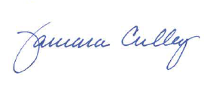

Tammy Culley
Purchasing Agent

TC/ch

