
ADDENDUM #1
RFB #26-0052
PUBLIC ELEVATOR UPGRADES MAIN COURTHOUSE

06/25/2026

The following is to ensure that vendors have complete information prior to submitting a Request for Bid. Here are some clarifications regarding RFB #26-0052 Public Elevator Upgrades Main Courthouse:

Questions and/or statements of clarification are in bold font, and answers to specific questions are italicized.

Please see attached. Project Manual and Drawings have been amended.

Firms interested in submitting a Request for Bid, must respond with complete information and deliver on or before 1:45 pm CDT, June 30, 2026. Late responses will not be accepted and will not receive consideration for final award.

“PLEASE ACKNOWLEDGE RECEIPT OF THIS ADDENDUM ON THE RFB RESPONSE PAGE.”

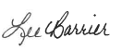

Lee Barrier, NIGP-CPP
Senior Purchasing Agent

LB/ks

TESSERE
1525 E. Douglas
Wichita, KS 67211

PUBLIC ELEVATOR UPGRADES MAIN COURTHOUSE
525 N. MAIN STREET, WICHITA, KS 67203

ARCHITECT'S PROJECT 00930R26001 ADDENDUM 1
Thursday, June 25, 2026
The original Project Manual and Drawings, dated May 14, 2026, for the Project noted above, are amended as indicated on this Addendum 1.
This Addendum consists of 20 pages and 3 Drawings.
Manufacturers approved by this Addendum shall not be relieved of the responsibility to comply with the specifications stated or, if not stated, the standard specifications and accessories supplied with the item specified.
Note: Receipt of this Addendum shall be acknowledged on your Bid Form. Failure to do so may subject the Bidder to disqualification.

ITEM NO.
CHANGES TO PRIOR ADDENDA (Does Not Apply) CHANGES TO BIDDING REQUIREMENTS (Does Not Apply)
INVITATION TO BID (Does Not Apply) INSTRUCTIONS TO BIDDERS (Does Not Apply)
CHANGES TO CONDITIONS OF THE CONTRACT (Does Not Apply) CHANGES TO SPECIFICATIONS

ADD 1-1 SECTION 142100 – ELECTRIC TRACTION ELEVATORS:
- Added non-proprietary requirements.
- Updated allowable manufacturers.
- Changed machine type from gearless to geared traction.
- Removed requirements for demand-based dispatching.
- Revised car enclosure finishes to No. 4 finish.
- Removed requirement to provide regenerative system.
- Refer to attached revised Section 142100.

CHANGES TO DRAWINGS

ADD 1-2 SHEET G-101 – CODE SUMMARY & SHEET INDEX:
- Updated Sheet Index.
- See attached Sheet for reference.

ADD 1-3 SHEET A-101 – ARCHITECTURAL FLOOR PLAN:
- Updated Detail C with additional keynotes.
- Updated Detail D with additional keynotes.
- Updated Sheet Keynote 4.
- Added Sheet Keynotes 8, 9, and 10.
- See attached Sheet for reference.

ADD 1-4 SHEET A-301 – BUILDING SECTIONS:
- Updated Detail 1 with additional keynotes.
- Updated Detail 3 with callout.
- Added Detail 5.
- Updated Sheet Keynote 1.
- Updated Sheet Keynote 3.
- Updated Sheet Keynote 5.
- Added Sheet Keynotes 8 through 14.
- See attached Sheet for reference.

ADD 1-5 SHEET E-100 – ELECTRICAL ELEVATOR PIT & SECOND FLOOR PLAN:
- Detail A: Revised Plan Note 8 to be a Plan Note 7.
- Plan Notes: Added Note 7 as Follows:
Provide junction box for 120V power connection to receptacle/light device on top of elevator cab. Contractor shall coordinate exact electrical termination location with Elevator Equipment Shop Drawings prior to bid.

ADD 1-6 SHEET E-101 – ELECTRICAL ELEVATOR PIT & SECOND FLOOR PLAN:
- Plan Notes: Revision to Plan Note 2 as Follows:
Elevator equipment manufacturer shall provide new emergency elevator selector switch at a location of the Owner's choosing. (This location shall be approved by the elevator inspector.) This new electrical switch panel shall have the ability to select the 3 new elevators for on/off operation when in emergency power mode. The panel shall also have provisions to add 3 future elevators. The elevator manufacturer shall provide and install all control wiring and contacts as required to achieve this operation. Modifications to the existing emergency transfer switch (located in the Penthouse) shall be made to add the additional control wires and contacts as required to indicate to the new emergency elevator selector switch that the elevators are in emergency mode. The existing emergency elevator selector switch in the elevator lobby of the first floor shall remain as is and remain operational for the 3 existing elevators that are not being upgraded at this time. This would be a temporary condition until the 3 remaining elevators are upgraded in the future.

ADD 1-7 SHEET E-200 – TWELFTH FLOOR PLAN & PENTHOUSE ELEVATOR FLOOR PLAN:

- General Note: Electrical Contractor shall add pre-signal wiring as required between the existing ATS (ATS-PME, as shown in Detail A/E-200) and the new elevator controllers. Electrical Contractor shall add contacts to the existing ATS as required to communicate between the new elevator controllers, new emergency elevator selector switch, and the new elevator status/location/operation panel (as noted in the Specification Section 142100, Article 2.8, Paragraph K.).

GENERAL
ADD 1-8 EXHIBIT A: See attached e-mail outlining required and non-required Scope items, as accepted by Chris Nordick with Metropolitan Area Building and Construction Department (3 pages).

ADD 1-9 Question: Do the elevators tie into a generator?
Answer: The elevators are supplied by emergency generator back-up system.

ADD 1-10 Question: Are the elevators on emergency back-up generator power?
Answer: The elevators are supplied by emergency generator back-up system.

ADD 1-11 Question: Is the penthouse fire rated?
Answer: Existing structure with no requirement to be altered. All NEW penetrations shall be sealed with fire stopping.

ADD 1-12 Question: Does 5 on A-301 imply that all "new" penetrations are to be filled with firestopping?
Answer: Keynote 5 on Sheet A-301 has been updated.
ADD 1-13 Question: What is the location of the existing storm drain indicated on Detail B on M-100?
Answer: Location of the existing storm drain is assumed in conjunction with existing drawings provided by the County. Discovery may be necessary by General Contractor.

ADD 1-14 Question: Is hoistway lighting at every level necessary? Are ledges necessary at horizontal beams at every level?
Answer: Not required as indicated in Inspector's notes on Sheet E-101.
ADD 1-15 Question: The specs call for regenerative drives, does the building have the ability to recoup?
Answer: No.
ADD 1-16 Question: Are the new stainless steel finishes to match the existing?
Answer: Finishes have been updated within the Specifications and are intended to be replaced in like kind.

ADD 1-17 Question: Should the destination dispatch control be removed from the elevator spec?
Answer: Refer to revised Specification Section 142100, attached.

ADD 1-18 Question: Is there an existing fire control panel?
Answer: Yes. The main panel is located at the control center.

ADD 1-19 Question: Are the north and south banks on the same call buttons?
Answer: Yes, and they are to be restored to such function upon modernization of the second phase at a later date.
ADD 1-20 Question: Are the elevator doors and cab doors being replaced?
Answer: Refer to updated keynotes on Sheets A-101 and A-301 for lobby doors and cab doors.

ADD 1-21 Question: The spec lists several manufacturers on page 76, section 2.3 A that I cannot obtain equipment from. I have requested to use Alpha controls as a substitution and have spoken to Sandy Anguelov about the matter but still need to verify.
Answer: Refer to updated Specifications for non-proprietary system. All substitutions must meet Specification requirements to be accepted.
ADD 1-22 Question: Page 77 of the spec, section 2.5 C asks for demand-based dispatching which typically implies destination control system. DCS is used by entering your floor number into a hall kiosk type fixture from each landing, you are then directed to the elevator you need, you enter the elevator, and it takes you to your desired floor. There are no traditional hall stations or car call buttons in the car station. This will add additional costs to the project. Can you confirm if this should be part of the requirements- it seems a little excessive.
Answer: Refer to revised Specification Section 142100, attached.

ADD 1-23 Question: Section 14 of the spec lists the hall station, car station, interior elevator handrails as #8 stainless steel. New cab interiors are part of the spec, but the existing elevator car fronts are #4 stainless steel. Can you confirm if #8 is correct? If it is correct do the elevator cab fronts (Transom, and 2 returns) need to be wrapped/cladded in #8 SS to match the new car stations?
Answer: Refer to revised Specification Section 142100, attached.
ADD 1-24 Question: Section 14 lists no door work as part of the scope; can you confirm if that is correct?
Answer: Refer to updated keynotes on Sheets A-101 and A-301 for lobby doors and cab doors.
ADD 1-25 Question: Regenerative drives are listed on page 77, section 2.4 A of the spec; can you confirm if this is really required? Regen elevator drives are designed to dump power back into the building's power grid, but the building has to be set up to receive it. Can you confirm if this is required? This may be an item to remove as it adds extra costs to the project.
Answer: Building does not have the ability to recoup regenerative power.
ADD 1-26 Question: Page 76, section 2.3 C, line 3 of the spec calls for gearless machines: the existing are geared machines. Geared machines are an acceptable choice for the speed/capacity/weight of the existing elevators and are more cost effective. Will geared machines be allowed in lieu of gearless?
Answer: Refer to revised Specification Section 142100, attached.

ADD 1-27 Question: Will the city provide parking for the onsite workers, or is this to be the responsibility of the contractors? (Sedgwick Co)
Answer: Once the County awards the Contract and the Notice to Proceed is issued, everyone working on-site will be issued a badge. The badge will provide free access to the parking garage located north of the Courthouse - 603 N. Main Street. Without presenting your badge during entry/exit, there will be a fee assessed to park in the employee/public garage. All street parking near the Courthouse is metered and maintained by the City of Wichita. It is on a first-come, first-served basis, and meters must be fed during the day, so time does not expire, or you will be ticketed by the City. The County cannot assist in any way if ticketed on a city street.

ADD 1-28 Question: Where will the access point for material be? Is there a planned staging area for equipment and tools? Typically, the storage area would be located at one of the bottom 2 floors. (Sedgwick Co)
Answer: Deliveries of materials/equipment can be dropped off at the loading dock at the Courthouse. The loading dock is a gated lot on the north side of the building. It is the Contractor's responsibility to receive the deliveries from the dock and haul to where they need to go. To help ensure a smooth process, deliveries should be coordinated with the Project Manager. Space within the Courthouse is extremely limited, as all floors are occupied and other construction projects are ongoing. Additionally, there is significant foot traffic due to courtroom activity, so safety measures must be adhered to at all times. It is critical that no tools or sharp items are left unattended at any time. Staging and storage are best confined to the 12th floor, where much of the work will occur.

END OF ADDENDUM 1

SECTION 142100 - ELECTRIC TRACTION ELEVATORS PART 1 - GENERAL
  - SUMMARY
    - Section Includes: Electric traction elevators.
    - Related Requirements:
      - Section 011000 "Summary" for purchase contract for elevators negotiated by Owner and assigned to Contractor.
      - Section 015000 "Temporary Facilities and Controls" for temporary use of elevators for construction purposes.
      - Section 092216 "Non-Structural Metal Framing" for the following:
        - Pit ladders.
        - Cants made from steel sheet in hoistways.
      - Section 221429 "Sump Pumps" for sump pumps, sumps, and sump covers in elevator pits.
      - Section 271513 "Communications Copper Horizontal Cabling" for twisted pair cabling for telephone service for elevators and for connection to elevator controllers for remote monitoring of elevator performance.

DEFINITIONS
    - Definitions in ASME A17.1/CSA B44 and UL 864 apply to work of this Section.
    - Service Elevator: A passenger elevator that is also used to carry freight.

ACTION SUBMITTALS
    - Product Data Submittals: Include capacities, sizes, performances, operations, safety features, finishes, and similar information. Include Product Data for operation, control, and signal systems.
    - Shop Drawings:
      - Include plans and large-scale details indicating locations of all components located in machine room and/or hoistway.
      - Include large-scale layout of car-control station and standby power operation control panel.
      - Indicate maximum average power demands and location of main line switch/shunt trip circuit breaker, switchboard panel, light switch, and feeder extension points in the machine room.
    - Samples for Initial Selection: For finishes involving color selection.

 | D. | Samples for Verification: For exposed car and signal equipment finishes; 3-inch-square Samples of sheet materials; and 4-inch lengths of running trim members.
1.4 |  | INFORMATIONAL SUBMITTALS
 | A. | Qualification Data: For installer.
 | B. | Manufacturer Certificates: Signed by elevator manufacturer certifying that hoistway, pit, and machine room layout and dimensions, as indicated on Drawings, and electrical service including standby power generator, as shown and specified, are adequate for elevator system being provided.
 | C. | Sample Warranty: For special warranty.
1.5 |  | CLOSEOUT SUBMITTALS
 | A. | Operation and Maintenance Data: For elevators to include in emergency, operation, and maintenance manuals.
 |  | - Submit manufacturer's or Installer's standard operation and maintenance manual, according to the 2022 version of ASME A17.1/CSA B44, including diagnostic and repair information available to manufacturer's and installer's maintenance personnel.
 | B. | Inspection and Acceptance Certificates and Operating Permits: As required by Authorities Having Jurisdiction for normal, unrestricted elevator use.
 | C. | Continuing Maintenance Proposal:
- Submit a continuing maintenance proposal from installer to Owner, in the form of a standard 5-year maintenance agreement, starting on date initial maintenance service is concluded. State services, obligations, conditions, and terms for agreement period and for future renewal options.
- Submit a continuing maintenance proposal from installer to Owner with terms, conditions, and obligations as set forth in, and in same form as, a "Draft of Elevator Maintenance Agreement," starting on date initial maintenance service is concluded.
1.6 |  | QUALITY ASSURANCE
 | A. | Installer Qualifications: Elevator manufacturer or an authorized representative who is trained and approved by manufacturer.
1.7 |  | DELIVERY, STORAGE, AND HANDLING
 | A. | Deliver, store, and handle materials, components, and equipment in manufacturer's protective packaging. Store materials, components, and equipment off of ground, under cover, and in a dry  location.

COORDINATION
    - Coordinate installation of inserts, sleeves, block outs, elevator equipment with integral anchors, and other items that are embedded in concrete or masonry for elevator equipment. Furnish templates, inserts, sleeves, elevator equipment with integral anchors, and installation instructions and deliver to Project site in time for installation.
    - Coordinate locations and dimensions of work specified in other Sections that relates to electric traction elevators including pit ladders; sumps and floor drains in pits; entrance subsills; electrical service; and electrical outlets, lights, and switches in hoistways, pits, and machine rooms.

WARRANTY
    - Manufacturer's Special Warranty: Manufacturer agrees to repair, restore, or replace elevator work that fails in materials or workmanship within specified warranty period.
      - Failures include, but are not limited to, operation or control system failure, including excessive malfunctions; performances below specified ratings; excessive wear; unusual deterioration or aging of materials or finishes; unsafe conditions; need for excessive maintenance; abnormal noise or vibration; and similar unusual, unexpected, and unsatisfactory conditions.
      - Warranty Period: 1 year from date of Substantial Completion.

PART 2 - PRODUCTS

2.1 |  | SOURCE LIMITATIONS
 | A. | Major elevator components, including driving machines, controllers, signal fixtures, door operators, car frames, cars, and entrances, to be manufactured by single manufacturer.
2.2 |  | NON-PROPRIETARY REQUIREMENTS
 | A. | All elevator equipment, controls, and systems must be non-proprietary, standard components that can be serviced and reprogrammed by technicians other than the original manufacturer.
2.3 |  | PERFORMANCE REQUIREMENTS
 | A. | Regulatory Requirements: Comply with the 2022 version of ASME A17.1/CSA B44.
 | B. | Accessibility Requirements: Comply with requirements for accessible elevators in the United States Access Board's ADA-ABA Accessibility Guidelines and with ICC A117.1.

  - ELECTRIC TRACTION ELEVATORS
    - Manufacturers: Subject to compliance with requirements, available manufacturers offering products that may be incorporated into the Work include, but are not limited to, the following:
      - Fujitec America, Inc.
      - KONE Inc.

MEI.
      - Mitsubishi Electric US, Inc.
      - Otis Worldwide Corporation.
      - Schindler Elevator Corp.
      - Schumacher Elevator Co.
      - ThyssenKrupp Elevator.
    - Elevator System, General: Non-proprietary elevator systems. Unless otherwise indicated, non-proprietary components to be used, as included in standard elevator systems and as required for complete system.
    - Elevator Description:
      - Group Number: 1.
      - Elevator Number(s): 001-003.
      - Machine Type: Geared traction.
      - Operation System: Group automatic operation with demand-based dispatching.
      - Auxiliary Operations:
        - Standby power operation.
        - Standby-powered lowering.
        - Battery-powered automatic evacuation.
        - Automatic dispatching of loaded car.
        - Nuisance-call cancel.
        - Loaded-car bypass.
        - Distributed parking.
        - Off-peak operation.
        - Automatic operation of lights and ventilation fans.
        - Emergency hospital and priority service at all floors.
      - Security Features: Car-to-lobby feature and lock-out function for single elevator designated as selected by Owner.
      - Car Enclosures:
        - Front Walls (Return Panels): Polished stainless steel, ASTM A480/A480M, No. 4 finish.
        - Car Fixtures: Polished stainless steel, ASTM A480/A480M, No. 4 finish.
        - Side and Rear Wall Panels: Plastic laminate selected by Architect from full range of manufacturer finishes.
        - Reveals: Polished stainless steel, ASTM A480/A480M, No. 4 finish.
        - Ceiling: Polished stainless steel, ASTM A480/A480M, No. 4 finish.
        - Handrails: 1/2-inch by 2 inches rectangular satin or brushed stainless steel.

        - Floor prepared to receive resilient flooring (specified in Section 096516 "Resilient Sheet Flooring.")
      - Hall Fixtures: Polished stainless steel, ASTM A480/A480M, No. 4 finish.
      - Additional Requirements:
        - Provide inspection certificate in each car, mounted under acrylic cover with frame made from polished stainless steel, ASTM A480/A480M, No. 4 finish.
        - Provide hooks for protective pads in lock-out car designated by Owner.

TRACTION SYSTEMS
    - Elevator Machines: Variable-voltage, variable-frequency, ac-type hoisting machines and solid-state power converters.
      - Provide regenerative system.
      - Limit total harmonic distortion of regenerated power to 5% per IEEE 519.
      - Provide means for absorbing regenerated power when elevator system is operating on standby power.
      - Provide line filters or chokes to prevent electrical peaks or spikes from feeding back into building power system.

OPERATION SYSTEMS
    - Provide non-proprietary microprocessor operation systems as required to provide type of operation indicated.
    - Group Automatic Operation with Demand-Based Dispatching: Provide reprogrammable group automatic system that assigns cars to hall calls based on a dispatching program designed to minimize passenger wait time. System automatically adjusts to demand changes for different traffic conditions including heavy incoming, heavy 2-way, heavy outgoing, and light off-hours as variations of normal 2-way traffic.
    - Auxiliary Operations:
      - Group Standby Power Operation: On activation of standby power, cars are returned to a designated floor and parked with doors open. One (1) car is returned at a time, with priority given to loaded cars. If a car cannot be returned after 2 attempts, it is removed from the system. When all cars have been returned or removed from the system, 1 car is automatically placed in service. If car selected for service cannot operate within 60 seconds, the system removes car from service and places another car in service. Cars can be manually put in service on standby power, either for return operation or for regular operation, by switches in control panel located at fire-command station. Manual operation causes automatic operation to cease.
      - Automatic Dispatching of Loaded Car: When car load exceeds 80% of rated capacity, doors begin closing.

      - Nuisance-Call Cancel: When car calls exceed a preset number while car load is less than a predetermined weight, all car calls are canceled. Preset number of calls and predetermined weight can be adjusted.
      - Loaded-Car Bypass: When car load exceeds 80% of rated capacity, car responds only to car calls, not to hall calls.
      - Distributed Parking: When cars are not required for response to calls, they are parked with doors closed and distributed in predetermined zones throughout the building. One zone to include the main floor and adjacent floors; remaining floors to be divided into approximately equal zones.
      - Off-Peak Operation: During periods of low traffic, half of the elevators in a group to be taken out of service and switched to low power mode.
      - Independent Service: Keyswitch in car-control station removes car from group operation and allows it to respond only to car calls. Key cannot be removed from keyswitch when car is in independent service. When in independent service, doors close only in response to door close button.
      - Priority Service: Service is initiated by a keyswitch at designated floors. One (1) elevator is removed from group operation and directed to the floor where service was initiated. On arriving at the floor, elevator opens its doors and parks and a lighted sign directs passengers to exit elevator. Car is placed in operation by selecting a floor and pressing door close button or by operating keyswitch to put car in independent service. After responding to floor selected or being removed from independent service, car is returned to group operation. If car is not placed in operation within a preset time after being called, it is returned to group operation.
      - Automatic Operation of Lights and Fan: When elevator is stopped and unoccupied with doors closed, lighting, ventilation fan, and cab displays are de-energized after 5 minutes and are re-energized before car doors open.
    - Security features are not to not affect emergency firefighters' service.
      - Keyswitch Operation: Push buttons are activated and deactivated by security keyswitches at car-control stations. Key is removable only in deactivated position.
      - Car-to-Lobby Feature: Feature, activated by keyswitch at main lobby, that causes car to return immediately to lobby and open doors for inspection. On deactivation by keyswitch, calls registered before keyswitch activation are completed and normal operation is resumed.

CAR ENCLOSURES
    - Materials and Finishes: Manufacturer's standards, but not less than the following:
      - Floor Finish: Specified in Section 096519 "Resilient Tile Flooring."
      - Plastic-Laminate Wall Panels: Plastic laminate adhesively applied with plastic-laminate panel backing and manufacturer's standard protective edge trim. Panels to have a flame-spread index of 75 or less, when tested according to ASTM E84. Plastic-laminate color, texture, and pattern as selected by Architect from plastic-laminate/elevator manufacturer's full range.
      - Fabricate car with recesses and cutouts for signal equipment.

      - Luminous Ceiling: Fluorescent light fixtures and ceiling panels of translucent acrylic or other permanent rigid plastic.
      - Ceiling: Metal flush panels, with 4 low-voltage downlights in each panel. Align ceiling panel joints with joints between wall panels.
      - Light Fixture: Efficiency: Not less than 35 lumens/W.
      - Ventilation Fan Efficiency: Not less than 3.0 cfm/W.

SIGNAL EQUIPMENT
    - Provide hall-call and car-call buttons that light when activated and remain lit until call has been fulfilled. Provide vandal-resistant buttons and lighted elements illuminated with LEDs.
    - Car-Control Stations: Provide non-proprietary recessed car-control stations. Mount in return panel adjacent to car door unless otherwise indicated.
      - Mark buttons and switches for required use or function. Use both tactile symbols and Braille.
      - Provide "No Smoking" sign matching car-control station, either integral with car-control station or mounted adjacent to it, with text and graphics as required by authorities having jurisdiction.
    - Emergency Communication System: Two (2)-way voice communication system, with visible signal, which dials preprogrammed number of monitoring station and does not require handset use. System is contained in flush-mounted cabinet, with identification, instructions for use, and battery backup power supply.
    - Firefighters' 2-Way Telephone Communication Service: Provide telephone jack in each car and required conductors in traveling cable for firefighters' 2-way telephone communication service specified in Section 284621.11 "Addressable Fire-Alarm Systems."
    - Car Position Indicator: Provide illuminated, digital-type car position indicator, located above car door or above car-control station. Also, provide audible signal to indicate to passengers that car is either stopping at or passing each of the floors served. Include travel direction arrows if not provided in car-control station.
    - Hall Push-Button Stations: To be replaced in like kind with current assembly. Two (2) hall push button stations at each landing for the group of 6 elevators.
      - Provide units with flat faceplate for mounting with body of unit recessed in wall.
      - Equip units with buttons for calling elevator and for indicating desired direction of travel.
      - Provide telephone jack in each unit for firefighters' two-way telephone communication service specified in Section 284621.11 "Addressable Fire-Alarm Systems."
    - Hall Lanterns: Units with illuminated arrows; but provide single arrow at terminal landings. Provide one of the following:
      - Non-proprietary wall-mounted units, for mounting above entrance frames.

      - Units with flat face plate for mounting with body of unit recessed in wall and with illuminated elements projecting from faceplate for ease of angular viewing.
      - Units mounted in both jabs of entrance frame for each elevator.
      - Units mounted in both car door jambs for 2-car groups.
    - Hall Annunciator: With each hall lantern, provide audible signals indicating car arrival and direction of travel. Signals sound once for up and twice for down.
      - At manufacturer's option, audible signals may be placed on cars.
    - Hall Position Indicators: Provide illuminated, digital-display-type position indicators, located above each hoistway entrance at ground floor. Provide units with flat faceplate and with body of unit recessed in wall.
      - Integrate ground-floor hall lanterns with hall position indicators.
    - Standby Power Elevator Selector Switches: Provide switches, as required by ASME A17.1/CSA B44, where indicated. Adjacent to switches, provide illuminated signal that indicates when normal power supply has failed. For each elevator, provide illuminated signals that indicate when they are operational and when they are at the designated emergency return level with doors open.
    - Fire-Command-Center Annunciator Panel: The elevator manufacturer shall provide custom wall-mounted panel containing illuminated position indicators for each of the elevators in the building. The panel shall indicate real-time elevator location and operational status for each elevator group and be clearly labeled with elevator designation. Panel shall also include illuminated signal that indicates when elevator is operational and when it is at the designated emergency return level with doors open. Provide standby power elevator selector switch(es), as required by ASME A17.1/CSA B44, adjacent to position indicators. Provide illuminated signal that indicates when normal power supply has failed. The panel shall be designed to graphically represent elevator grouping and floor numbering for all 8 elevators in the building. Submittal for annunciator panel shall be provided to Architect/Engineer for review. Elevator manufacturer shall coordinate exact installation location of panel with owner prior to rough in.
    - Emergency Pictorial Signs: Fabricate from materials matching hall push-button stations, with text and graphics as required by Authorities Having Jurisdiction, indicating that in case of fire, elevators are out of service and exits should be used instead. Provide 1 sign at each hall push-button station unless otherwise indicated.

FINISH MATERIALS
    - Hot-Rolled Steel Sheet: ASTM A1011/A1011M, commercial steel, Type B, pickled.
    - Stainless-Steel Sheet: ASTM A240/A240M, Type 304.
    - Stainless-Steel Bars: ASTM A276/A276M, Type 304.
    - Stainless-Steel Tubing: ASTM A554, Grade MT 304.

PART 3 - EXECUTION

  - EXAMINATION
    - Examine elevator areas, with installer present, for compliance with requirements for installation tolerances and other conditions affecting performance of the Work. Examine hoistways, hoistway openings, pits, and machine rooms as constructed; verify critical dimensions; and examine supporting structure and other conditions under which elevator work is to be installed.
    - Prepare written report, endorsed by installer, listing conditions detrimental to performance of the Work.
    - Proceed with installation only after unsatisfactory conditions have been corrected.

INSTALLATION OF ELECTRIC TRACTION ELEVATORS
    - Comply with manufacturer's written instructions.
    - Welded Construction: Provide welded connections for installing elevator work where bolted connections are not required for subsequent removal or for normal operation, adjustment, inspection, maintenance, and replacement of worn parts. Comply with AWS standards for workmanship and for qualifications of welding operators.
    - Sound Isolation: Mount rotating and vibrating equipment on vibration-isolating mounts to minimize vibration transmission to structure and structure-borne noise due to elevator system.
    - Lubricate operating parts of systems, including ropes, as recommended by manufacturers.
    - Alignment: Coordinate installation of hoistway entrances with installation of elevator guide rails for accurate alignment of entrances with car. Where possible, delay final adjustment of sills and doors until car is operable in shaft. Reduce clearances to minimum, safe, workable dimension at each landing.
    - Leveling Tolerance: 1/8-inch, up or down, regardless of load and travel direction.
    - Set sills flush with finished floor surface at landing. Fill space under sill solidly with nonshrink, nonmetallic grout.
    - Locate hall signal equipment for elevators as follows unless otherwise indicated:
      - For groups of elevators, locate hall push-button stations between 2 elevators at center of group or at location most convenient for approaching passengers.
      - Place hall lanterns either above or beside each hoistway entrance.
      - Mount hall lanterns at a minimum of 72 inches above finished floor.

    - Annunciator Panel:
      - Enclosure shall be cold-rolled steel with welded and ground seams finished with a black powder texture.
      - Door: Attached with concealed stainless-steel piano hinge. Door fastened with keyed lock with no other fasteners visible. Finished with a powder-textured finish.
      - Engraved metal faceplate or listed touchscreen.
      - LED or graphical indicators visible under emergency lighting.
      - Permanently labeled floor identifiers.

FIELD QUALITY CONTROL
    - Acceptance Testing: On completion of elevator installation and before permitting elevator use (either temporary or permanent), perform acceptance tests as required and recommended by ASME A17.1/CSA B44 and by governing regulations and agencies.
    - Advise Owner, Architect, and Authorities Having Jurisdiction in advance of dates and times that tests are to be performed on elevators.

PROTECTION
    - Temporary Use: Limit temporary use for construction purposes to one elevator. Comply with the following requirements for each elevator used for construction purposes:
      - Provide car with temporary enclosure, either within finished car or in place of finished car, to protect finishes from damage.
      - Provide strippable protective film on entrance and car doors and frames.
      - Provide padded wood bumpers on entrance door frames covering jambs and frame faces.
      - Provide other protective coverings, barriers, devices, signs, and procedures as needed to protect elevator and elevator equipment.
      - Do not load elevators beyond their rated weight capacity.
      - Engage elevator Installer to provide full maintenance service. Include preventive maintenance, repair or replacement of worn or defective components, lubrication, cleanup, and adjustment as necessary for proper elevator operation at rated speed and capacity. Provide parts and supplies same as those used in the manufacture and installation of original equipment.
      - Engage elevator installer to restore damaged work, if any, so no evidence remains of correction. Return items that cannot be refinished in the field to the shop, make required repairs and refinish entire unit, or provide new units as required.

MAINTENANCE SERVICE
    - Initial Maintenance Service: Beginning at Substantial Completion, maintenance service to include
12 months' full maintenance by skilled employees of elevator installer. Include monthly preventive maintenance, repair or replacement of worn or defective components, lubrication,

cleaning, and adjusting as required for proper elevator operation at rated speed and capacity. Parts and supplies to be manufacturer's authorized replacement parts and supplies.
- Perform maintenance during normal working hours.
- Perform emergency callback service during normal working hours with response time of 2 hours or less.
- Include 24-hour-per-day, 7-day-per-week emergency callback service with response time of 2 hours or less.

DEMONSTRATION
    - Engage a factory-authorized service representative to train Owner's maintenance personnel to operate, adjust, and maintain elevator(s).
    - Check operation of each elevator with Owner's personnel present before date of Substantial Completion and again not more than 1 month before end of warranty period. Determine that operation systems and devices are functioning properly.

END OF SECTION 142100

Nick Kurth
From: Nordick, Chris <Chris.Nordick@sedgwick.gov>
Sent: Tuesday, April 21, 2026 2:47 PM
To: Nick Kurth; Drew Rose
EXHIBIT A

Cc: Gary Stefan; David Ahlstedt; Phil Voegeli; Christian Kaufman; Brady Norell
Subject: Re: (EXTERNAL)RE: Sedgwick Co - Main Courthouse Elevators

⚐ Sent from external sender ⚐

Nick.
I agree with all points indicated in this email. I will attach this email to the permits once obtained.

Respectfully

Chris A Nordick, QEI | Chief Electrical & Elevator Inspector | Metropolitan Area Building and Construction Department
Direct: (316) 660-1736 | Main: (316) 660-1840 | chris.nordick@sedgwick.gov The Ronald Reagan Building | 271 W. 3rd Street, Suite 301 | Wichita, KS 67202 www.sedgwickcounty.org | Facebook | Twitter

“The support of truth takes integrity.” “People with integrity do what they say they are going to do. Others have excuses.” “The foundation stones for a balanced success are honesty, character, integrity, faith, love and loyalty.”

Notice: The information contained in this message is intended only for the personal and confidential use of the recipients named above. If the reader of this message is not the intended recipient, you are hereby notified that you have received this document in error and that any review, dissemination, distribution, or copying of this message is strictly prohibited. If you have received this communication in error, please notify the sender immediately by telephone and delete the message from your system.
For permitting and/or licensing, please call 660-1840 or email at MABCD@sedgwick.gov

From: Nick Kurth <nick.kurth@tessere.com>
Sent: Tuesday, April 21, 2026 2:31 PM
To: Nordick, Chris <chris.nordick@sedgwick.gov>; Drew Rose <drose@iconengineers.net>
Cc: Gary Stefan <gstefan@iconengineers.net>; David Ahlstedt <dahlstedt@iconengineers.net>; Phil Voegeli
<pvoegeli@iconengineers.net>; Christian Kaufman <christian.kaufman@tessere.com>; Brady Norell
<brady.norell@tessere.com>
Subject: (EXTERNAL)RE: Sedgwick Co - Main Courthouse Elevators
CAUTION: This email originated from outside of the organization. Do not click links or open attachments unless you recognize the sender and know the content is safe. Sedgwick County Division of Information Technology
Chris,
Thank you for touching base a couple weeks ago on the Main Courthouse Elevator Modernization. I am following up with our notes, please see below.

In accordance with 2022 A17.1 Section 8.7 Alterations the modernization of the elevators the Sedgwick County’s Main Courthouse does require the following:
- Will require its own receptacle, its own pit lights, and its own sump pump each to be on its own circuit for each of the (3) three elevators.
- The design team will work with the elevator manufacture to provide a new annunciator panel in the Command Center location of Sedgwick County Courthouse that indicates the visual location of the elevators and whether they are operational or not.
The following will NOT be required:
- Lighting at each level will not be required. The shaft will not be upgraded and will remain as an existing condition.
- Feeders to elevators will not be upgraded but reconnected to new equipment
- Voice, remote off site, and emergency communication will not be required to common location at security with-in building unless required by elevator upgrade0
- Elevator Shaft Pressurization: Per our discussion on the Teams Meeting on April 9th, pressurization of the elevator shafts at Sedgwick County Courthouse will not be a requirement for the modernization elevator project.
Please provide confirmation on each item. Thank you,

NICK KURTH | AIA + NCIDQ + IIDA
Project Architect | Interior Designer Office: 316.265.9367

Website | Facebook | Instagram | YouTube | LinkedIn
The information transmitted by this e-mail is intended for the exclusive use of the addressee and may contain confidential and/or privileged material. If you receive this e-mail in error, please contact the sender immediately at the telephone number listed above, and delete the communication from any computer or network system.

-----Original Appointment-----
From: Nick Kurth
Sent: Monday, April 6, 2026 10:28 AM
To: Nick Kurth; Nordick, Chris; Drew Rose
Cc: Gary Stefan; David Ahlstedt; Phil Voegeli; Christian Kaufman; Brady Norell
Subject: Sedgwick Co - Main Courthouse Elevators
When: Thursday, April 9, 2026 1:30 PM-2:00 PM (UTC-06:00) Central Time (US & Canada).
Where: Microsoft Teams Meeting

Microsoft Teams meeting Join:
teams invite
Meeting ID: 264 297 848 984 60

Passcode: Di2Uk6YC

Need help? | System reference

Dial in by phone
+1 316-247-3526,,649150273# United States, Andover Find a local number
Phone conference ID: 649 150 273#

For organizers: Meeting options | Reset dial-in PIN

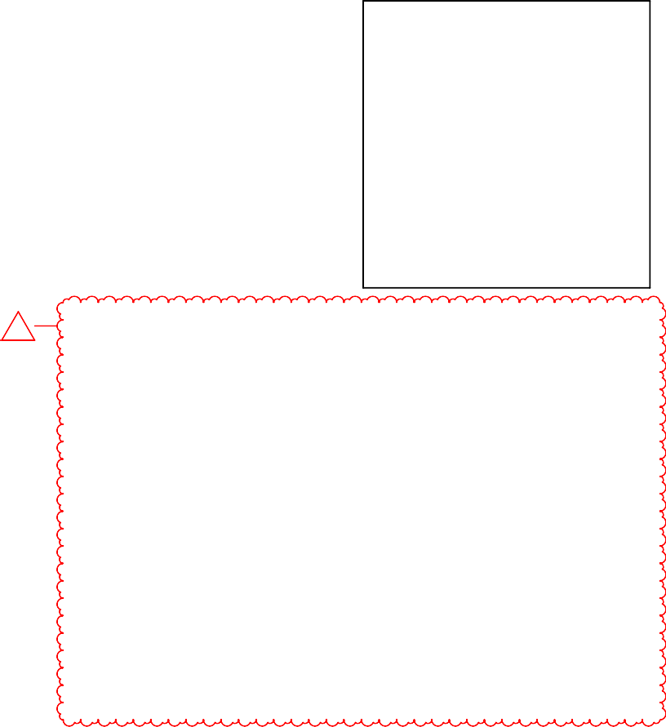
www.tessere.com
ADD01
All work herein is the exclusive property of TESSERE and is not to be copied or used in any way without the express written consent of TESSERE. All drawings, specifications, ideas, designs, and arrangements appearing herein constitute the original and unpublished Work of:
SHEET INDEX
### | SHEET NUMBER | SHEET NAME | REVISION NO.
01 [G] GENERAL
001 | G-001 | COVER SHEET
002 | G-101 | CODE SUMMARY & SHEET INDEX | ADD01
003 | G-102 | CODE FLOOR PLAN
08 [A] ARCHITECTURAL
004 | A-001 | GENERAL NOTES, LEGENDS, SYMBOLS, & ABREVIATIONS
005 | A-101 | ARCHITECTURAL FLOOR PLAN | ADD01
006 | A-301 | BUILDING SECTIONS | ADD01
14 [MP] MECHANICAL/PLUMBING
007 | M-100 | MECHANICAL / PLUMBING PLANS
15 [E] ELECTRICAL
008 | E-100 | ELECTRICAL ELEVATOR PIT, SECOND FLOOR PLAN
009 | E-101 | ELECTRICAL FIRST FLOOR ELEVATOR PLAN
010 | E-200 | ELECTRICAL PENTHOUSE, TWELFTH FLOOR PLAN

© 2026 TESSERE
PUBLIC ELEVATOR UPGRADES
CODE ANALYSIS
SUMMARY OF GOVERNING REGULATIONS:
AUTHORITY HAVING JURISDICTION: LOCAL: [LOCAL BUILDING INSPECTION DEPARTMENT
INFORMATION]

CODE TITLE EDITION
BUILDING CODE INTERNATIONAL BUILDING CODE (IBC) 2024
EXISTING BUILDING CODE INTERNATIONAL EXISTING BUILDING CODE (IEBC) 2024
ACCESSIBILITY CODE ADA STANDARDS FOR ACCESSIBLE DESIGN 2010
MECHANICAL CODE INTERNATIONAL MECHANICAL CODE (IMC) 2024
INTERNATIONAL FUEL GAS CODE (IFGC) 2024
PLUMBING CODE UNIFORM PLUMBING CODE (UPC) 2021
ELECTRICAL CODE NFPA 70 - NATIONAL ELECTRICAL CODE (NEC) 2023
FIRE PREVENTION INTERNATIONAL FIRE CODE (IFC) 2024
LIFE SAFETY NFPA 10 - PORTABLE FIRE EXTINGUISHER 2022
NFPA 13 - INSTALLATION OF SPRINKLER SYSTEMS 2022
NFPA 72 - NATIONAL FIRE ALARM CODE 2022
KAR22-1 KANSAS FIRE PREVENTION CODE

USE AND OCCUPANCY:

USE GROUP OCCUPANCY CLASSIFICATION IBC
USE GROUPS BELOW ARE ASSUMED AND UNCHANGED
GROUP 'A' ASSEMBLY Sect 303
GROUP 'B' BUSINESS Sect 304

GENERAL BUILDING HEIGHTS AND AREAS:
IBC BUILDING HEIGHT ALLOWABLE(FT) ACTUAL(FT) Table 504 TYPE I-A UNCHANGED UNCHANGED
IBC BUILDING AREA ALLOWABLE(SF) ACTUAL(SF) Sect 506.2 TYPE I-A UNCHANGED UNCHANGED

TYPE OF CONSTRUCTION:

CONSTRUCTION CLASSIFICATION IBC
TYPE I-A Table 601

BUILDING ELEMENT FIRE-RESISTANCE RATING (HR) IBC
TYPE I-A Table 601
PRIMARY STRUCTURAL FRAME 3
BEARING WALLS
EXTERIOR 3
INTERIOR 3
NONBEARING WALLS & PARTITIONS
EXTERIOR SEE TABLE 705.5
INTERIOR 0
FLOOR CONSTRUCTION AND
ASSOCIATED SECONDARY MEMBERS 2
ROOF CONSTRUCTION AND
ASSOCIATED SECONDARY MEMBERS 1-1/2

COMBUSTIBLE MATERIAL IN TYPES I & II CONSTRUCTION IBC
COMBUSTIBLE MATERIALS PERMITTED AS INDICATED Sect 603.1
FIRE AND SMOKE PROTECTION: PENETRATIONS IBC
THROUGH FIRE-RESISTANCE RATED PARTITIONS Sect 714.4.1

THERMAL AND SOUND INSULATING MATERIALS IBC
CONCEALED INSULATION FLAME SPREAD INDEX < 25 Sect 720.2
SMOKE DEVELOPED < 450

INTERIOR FINISHES:

INTERIOR WALL AND CEILING FINISH REQUIREMENTS BY OCCUPANCY IBC OCCUPANCY GROUP CONDITION CLASS Table 803.13 GROUP 'B' SPRINKLERED BUILDING
INTERIOR EXIT STAIRWAYS B CORRIDORS & ENCLOSURE FOR
EXIT ACCESS STAIRWAY C
ROOMS & ENCLOSED SPACES C
FIRE PROTECTION SYSTEMS: AUTOMATIC SPRINKLER SYSTEMS IBC
AUTOMATIC FIRE EXTINGUISHER SYSTEM PROVIDED THROUGHOUT BUILDING Sect 903 (EXISTING)

STANDPIPE SYSTEMS CLASS IBC
STANDPIPES INSTALLED (EXISTING) CLASS I Sect 905.3.1

FIRE ALARM AND DETECTION SYSTEMS IBC
Sect 907.2
FIRE ALARM SYSTEM: EXISTING UNCHANGED

MEANS OF EGRESS:

UNCHANGED



ADD01 ADD01 06/25/2026
525 N Main St, Wichita, KS, 67203
DESCRIPTION
DATE

PROJECT NO: STATUS:
DATE: DRAWN BY: CHECKED BY:
00930R26001

100% CDs

05/14/2026
BWN NLK

CODE SUMMARY & SHEET INDEX
SHEET SEQ: 002
PLOT DATE: 6/17/2026 4:10:54 PM
FILE PATH: Autodesk Docs://00930R26001-Sedgwick-CO-Courthouse-Elev/00930R26001_Sedgwick CO_Crths Elev R1_V26.rvt

G-101


www.tessere.com
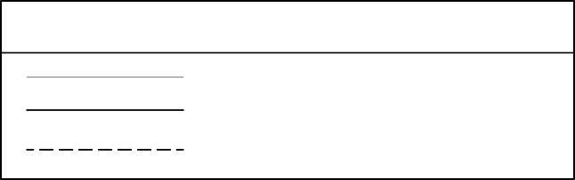
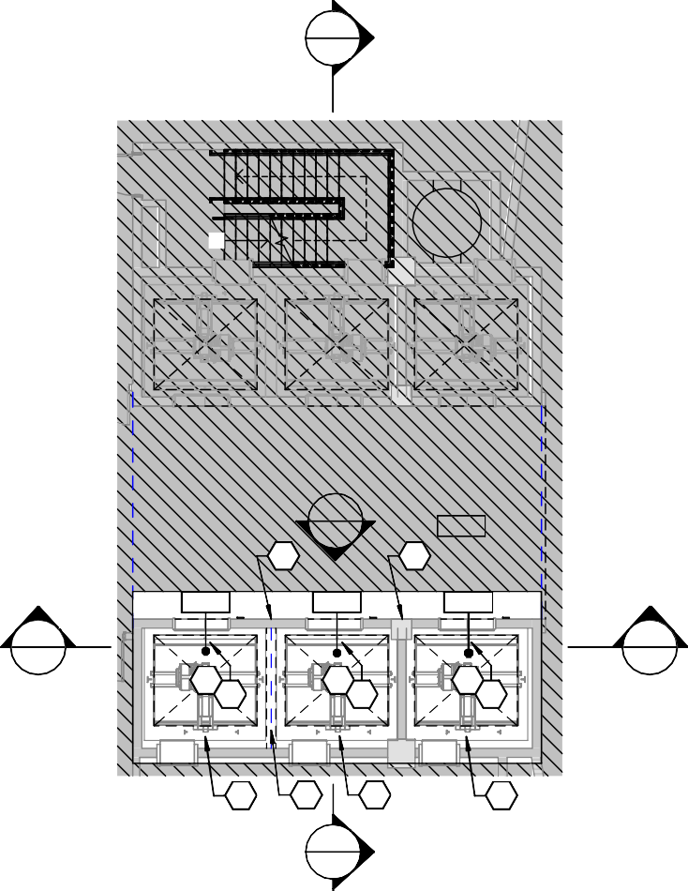
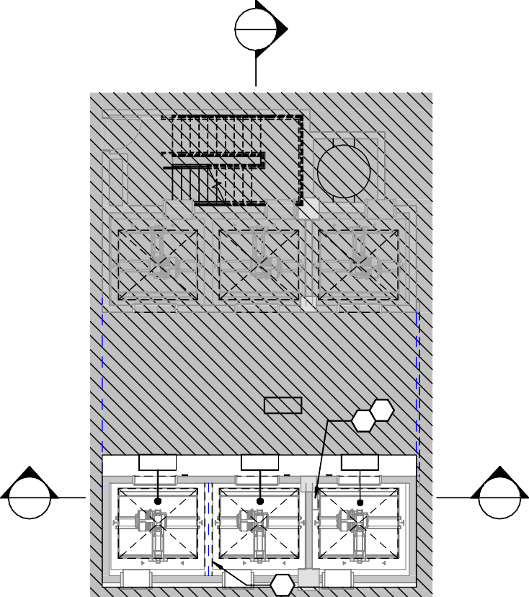

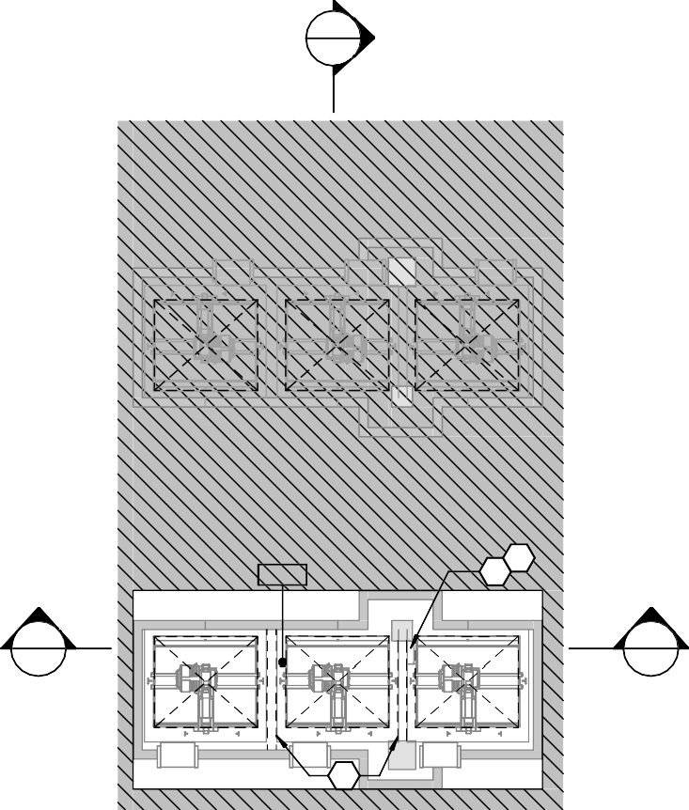
All work herein is the exclusive property of TESSERE and is not to be copied or used in any way without the express written consent of TESSERE. All drawings, specifications, ideas, designs, and arrangements appearing herein constitute the original and unpublished Work of:
LINETYPE LEGEND
LIGHT THIN LINE INDICATES EXISTING ELEMENT TO REMAIN HEAVY SOLID LINE INDICATES NEW ELEMENT
HEAVY DASHED LINE INDICATES EXISTING ELEMENT TO BE REMOVED IN ITS ENTIRETY
2
A-301
UP
3
A-301
ELEVATOR LOBBY
101
8 8
ELEVATOR
102
ELEVATOR
103
ELEVATOR
104
1
A-301
1
A-301
7
10
7
10
7
10
9
4
9
9
2
A-301
2
A-301
ELEVATOR LOBBY
001
1
2
ELEVATOR
102
ELEVATOR
103
ELEVATOR
104
1
A-301
1
A-301
4
2
A-301
2
A-301
ELEVATOR PIT
000
1
2
1
A-301
1
A-301
3
© 2026 TESSERE

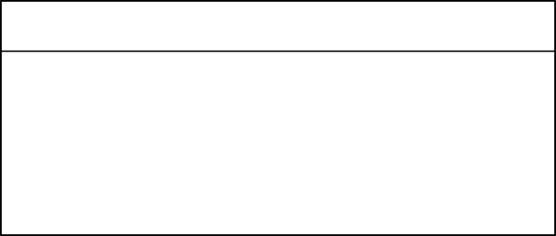
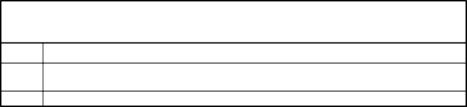
HATCH LEGEND
AREA NOT IN SCOPE OF WORK U.N.O.
EXISTING WALL / PARTITION TO REMAIN U.N.O.
NEW WALL / PARTITION CONSTRUCTION U.N.O.
GENERAL NOTES
#
A

B
NOTES
CENTER ALL CEILING-MOUNTED EQUIPMENT/DEVICES AT CENTER OF CEILING TILES UNLESS NOTED OTHERWISE. COORDINATE WITH MECHANICAL/ELECTRICAL DRAWINGS.
ALL DIMENSIONS FROM EXISTING WALLS ARE FROM FINISHED FACE OF WALL.



2
A-301

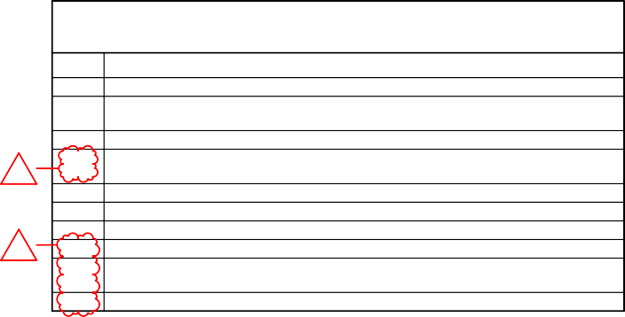

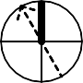
A ELEVATOR PIT
SHEET KEYNOTES
# DESCRIPTION
1
2

3
4
ADD01
ADD01
5
6
7
8
9
10
DEMO EXISTING PIT LADDER
NEW PIT LADDER: BASIS OF DESIGN SMART LADDER BY SMART ELEVATOR TECH. REFER TO ELECTRICAL DRAWINGS.
OVERHEAD STRUCTURAL BEAM
NEW SLOPED CONSTRUCTION AT ALL HORIZONTAL BEAMS IN HOISTWAY WHERE HORIZONTAL SURFACES EXCEED 4 INCHES. REFER TO DETAIL 4/A-301.
EXISTING FLOOR HATCH TO REMAIN EXISTING PENTHOUSE STAIR TO REMAIN NEW INTERIOR CAB FINISHES PER SCHEDULE
CALL BUTTONS TO BE REPLACED AT EVERY LEVEL
ELEVATOR MANUFACTURER TO REBALANCE EACH ELEVATOR AND PROVIDEADDITIONAL COUNTERWEIGHT AS NEEDED
CAB DOOR ROLLING HARDWARE TOP BE REPLACED. ELEVATOR CAB DOOR TO REMAIN.

BASEMENT

1/8" = 1'-0"
0 4' 8' 16'

1/8" = 1'-0"
0 4' 8' 16'



2
A-301

PROJECT NO: STATUS:
DESCRIPTION
DATE
4'-6"
10'-11"
ROOM | FINISH SCHED | ULE |  | FINISHES / MATERIALS  WALLS |  |  |  |  | P | 525
ROOM NO | ROOM NAME | FLOOR | BASE | NORTH | EAST | SOUTH | WEST | CEILING
102 | ELEVATOR | RB1 | MT | WP-1 | WP-1 + HR-1 | WP-1 + HR-1 | WP-1 + HR-1 | EC
103 | ELEVATOR | RB1 | MT | WP-1 | WP-1 + HR-1 | WP-1 + HR-1 | WP-1 + HR-1 | EC
104 | ELEVATOR | RB1 | MT | WP-1 | WP-1 + HR-1 | WP-1 + HR-1 | WP-1 + HR-1 | EC
 |  |  |  |  |  |  |  |  | ADD01 ADD01 | 06/25/2026

00930R26001

100% CDs

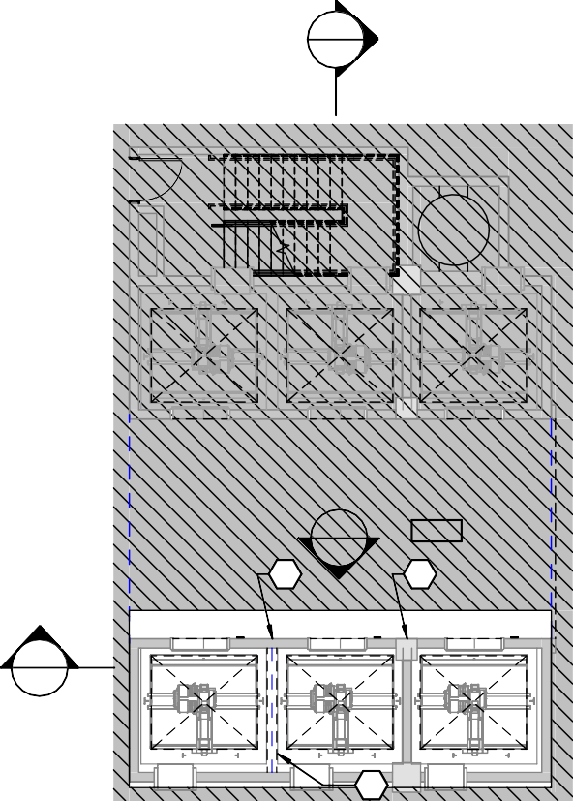
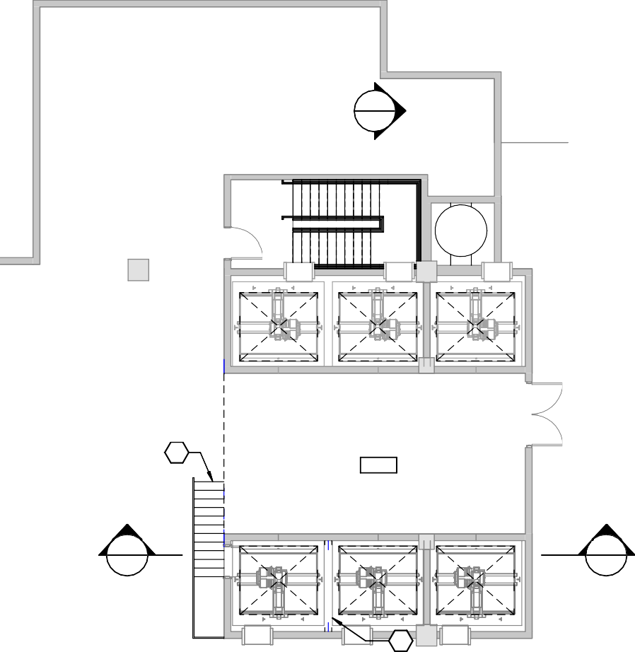
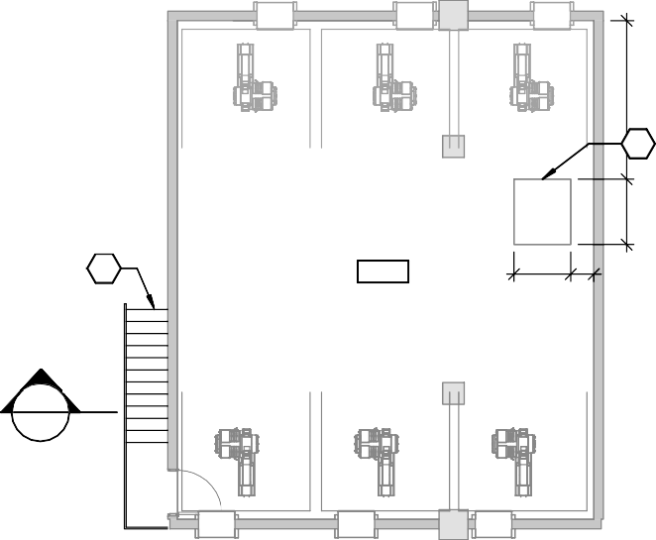
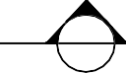
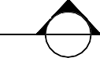
DATE: DRAWN BY: CHECKED BY:
2
A-301
3
A-301
ELEVATOR LOBBY
201
8 8
1
A-301
4
2
A-301
6
MECHANICAL
1201
1
A-301
1
A-301
4
5
6
PENTHOUSE
1301
3'-11" 1'-7"
1
A-301
1
A-301

1
A-301
05/14/2026
BWN NLK



2
A-301

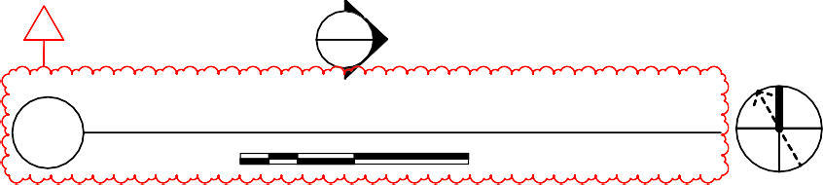
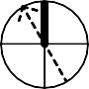

TWELFTH FLOOR
ADD01
2
A-301
D
SECOND THROUGH ELEVENTH FLOOR
1/8" = 1'-0"
0
4'
8'
16'
E
1/8" = 1'-0"
0 4' 8' 16'



2
A-301


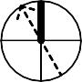
PENTHOUSE
F
1/8" = 1'-0"
0 4' 8' 16'

ARCHITECTURAL FLOOR PLAN

A-101

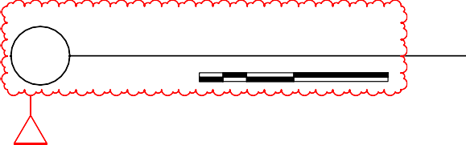

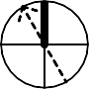
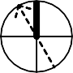
C
FIRST FLOOR
1/8" = 1'-0"
0
4'
8'
16'
ADD01
B
SHEET SEQ: 005
PLOT DATE: 6/17/2026 4:10:57 PM
FILE PATH: Autodesk Docs://00930R26001-Sedgwick-CO-Courthouse-Elev/00930R26001_Sedgwick CO_Crths Elev R1_V26.rvt
UBLIC ELEVATOR UPGRADES
N Main St, Wichita, KS, 67203
FINISH CODES
LOCATION MARK MATERIAL DESCRIPTION
BASE
BASE | MT | METAL TOE KICK | FLAT STAINLESS
CEILING
CEILING | EC | ELEVATOR CEILING | MANUFACTURER'S FULL RANGE OF AVAILABLE FINISHES
FLOORS
FLOORS | RB-1 | RUBBER FLOOR TILE | MANUFACTURER'S FULL RANGE OF AVAILABLE FINISHES
MISCELLANEOUS
MISCELLANEOUS | HR-1 | HANDRAIL (ELEVATOR) | MANUFACTURER'S FULL RANGE OF AVAILABLE FINISHES
MISCELLANEOUS | RV | METAL REVEALS | MANUFACTURER'S FULL RANGE OF AVAILABLE FINISHES
PAINT
PAINT | PNT-1 | PAINT | MATCH EXISTING
WALLS
WALLS | WP | HORIZONTAL WALL PANELS | MANUFACTURER'S FULL RANGE OF AVAILABLE FINISHES

www.tessere.com
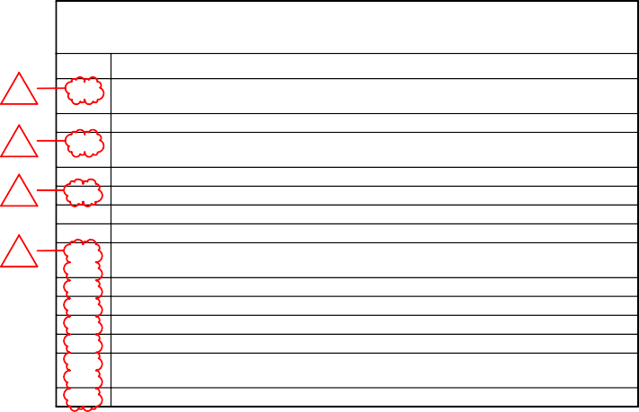
All work herein is the exclusive property of TESSERE and is not to be copied or used in any way without the express written consent of TESSERE. All drawings, specifications, ideas, designs, and arrangements appearing herein constitute the original and unpublished Work of:
SHEET KEYNOTES
ADD01
#
1
ADD01
2
3
ADD01
ADD01
4
5
6
7
8

9
10
11
12
13

14
DESCRIPTION
NEW SLOPED CONSTRUCTION AT ALL HORIZONTAL BEAMS IN HOISTWAY WHERE HORIZONTAL SURFACES EXCEED 4 INCHES. REFER TO DETAIL 4/A-301.
ALL STAINLESS FINISH SURFACES: REVEALS, TRIM, AND HANDRAILS BY ELEVATOR PROVIDER
NEW WALL PANELS WP-1 BY ELEVATOR PROVIDER. ARCH TO SELECT FROM MANUFACTURER'S FULL RANGE OF FINISHES
NEW RB-1 FLOORING INSTALLED BY GC, OWNER PROVIDED TO INCLUDE COUNTY SEAL SEAL ALL NEW PENETRATIONS WITH FIRESTOPPING
DEMO EXISTING PIT LADDER
NEW SIGNAGE PER ELEVATOR TO BE PROVIDED BY GC AT EVERY LEVEL
NEW PIT LADDER: BASIS OF DESIGN SMART LADDER BY SMART ELEVATOR TECH. REFER TO ELECTRICAL DRAWINGS
LEVEL INDICATOR ABOVE DOOR TO BE REPLACED AND INSTALLED AT EVERY LEVEL DIRECTIONAL INDICATOR TO BE REPLACED AND ADDED AT EVERY LEVEL
LEVEL SIGNAGE AT JAMB TO BE REPLACED AT EVERY LEVEL DIRECTIONAL INDICATOR TO BE ADDED AT JAMB AT EVERY LEVEL
LOBBY DOOR ROLLING HARDWARE TO BE REPLACED. EXISTING ELEVATOR LOBBY DOORS TO REMAIN
CALL BUTTONS TO BE REPLACED IN PLACE AT EVERY LEVEL
© 2026 TESSERE



2
A-301

1
A-301

PENTHOUSE
ROOF 258' - 0"
ROOF
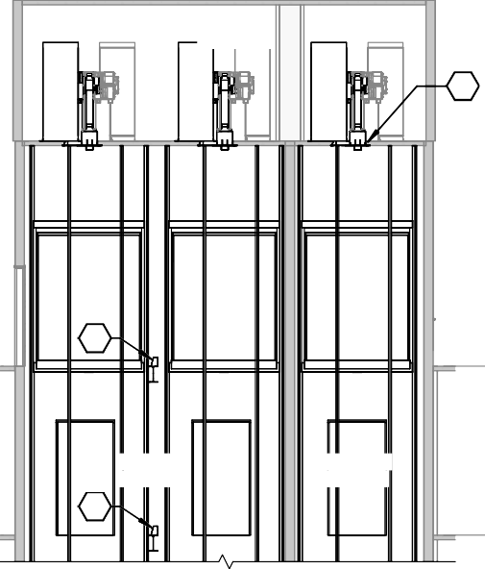
258' - 0"

PENTHOUSE

5

PENTHOUSE
248' - 0"

5
PENTHOUSE
248' - 0"

MECHANICAL
PUBLIC ELEVATOR UPGRADES

1
TWELFTH FLOOR
232' - 0"

1
TWELFTH FLOOR
232' - 0"

ELEVATOR HOISTWAY
1

ELEVATOR HOISTWAY

ELEVENTH FLOOR
220' - 0"
ELEVATOR LOBBY
ELEVATOR HOISTWAY

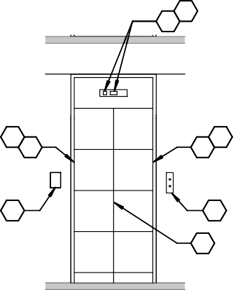
1
9
10
12
11
11
12
7
14
13
ELEVEN TH FLOOR
220' - 0"

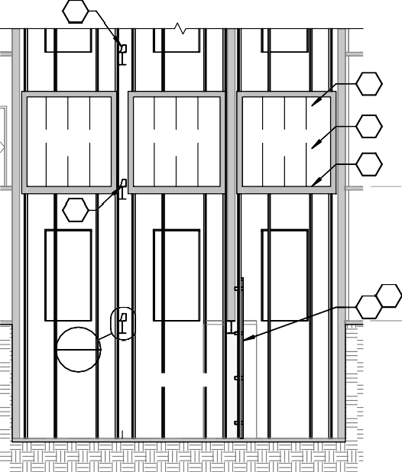
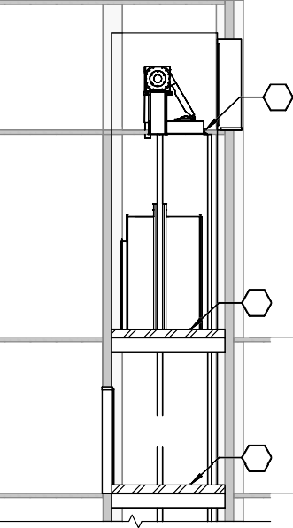
1

SECON D FLOOR
112' - 0"
2

1

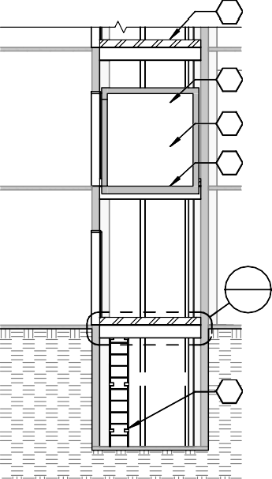

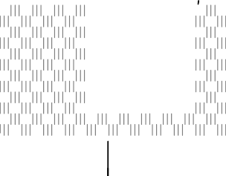
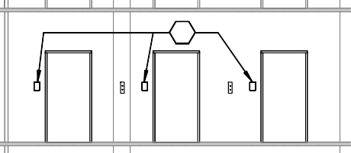

SECOND FLOOR
2
A-301
7
525 N Main St, Wichita, KS, 67203
112' - 0"
2

ELEVATOR CAB

1

ELEVATOR CAB

ELEVATOR CAB
3

4
FIRST FLOOR
100' - 0"
ELEVATOR LOBBY
ELEVATOR CAB
3

4
FIRS T FLOOR
100' - 0"
SIX TH FLOOR
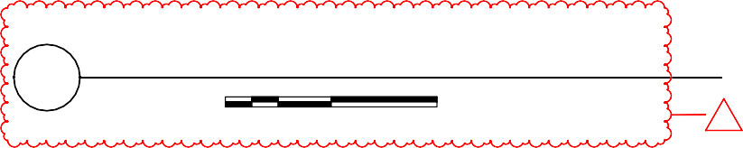
160' - 0"
5
TYPICAL ELEVATOR DOOR ELEVATION
1/4" = 1'-0"
0
2'
4'
8'
ADD01

4
A-301

8
6 BASEMENT
88' - 0"
ELEVATOR LOBBY

ELEVATOR

4
A-301
BASEMENT
88' - 0"
FIF TH FLOOR
148' - 0"

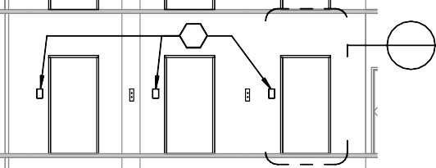
SECOND FLOOR
112' - 0"
7 5
A-301

2" 4"

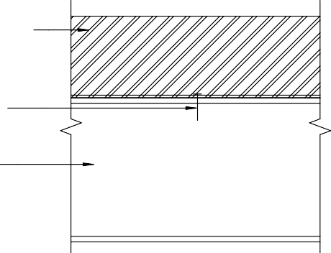
1/4" BENT STEEL PLATE,

ADD01 ADD01 06/25/2026
DESCRIPTION
DATE

ELEVATOR PIT

ELEV ATOR PIT
77' - 6"
PIT

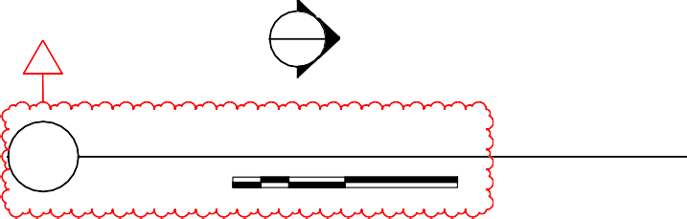
1
2
A-301
ADD01
1
SECTION EW
1/8" = 1'-0"
0
4'
8'
16'
6

ELEVATOR PIT
77' - 6"

FIR ST FLOOR
100' - 0"
ASTM A36 COMPLIANT. PROVIDE WITHOUT SEAM MARKS OR BLEMISHES.

STAINLESS STEEL FASTENER
7 3/4"

EXISTING STEEL BEAM TO REMAIN
PROJECT NO: STATUS:
DATE: DRAWN BY: CHECKED BY:
00930R26001

100% CDs

05/14/2026
BWN NLK

A-301


SECTION NS
2
1/8" = 1'-0"
0 4' 8' 16'

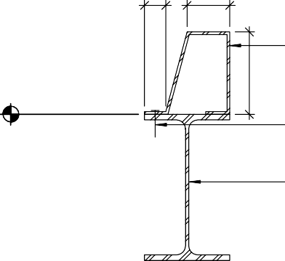
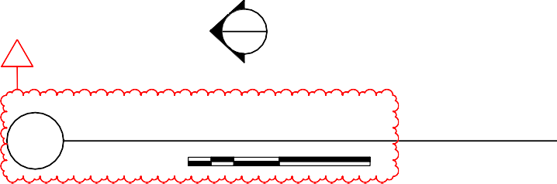

4 BEAM ANGLE DETAIL
MAX
BASEMENT 88' - 0"
SIMILAR AT OTHER LEVELS
2
A-301
ADD01
3
STANDARD ELEVATION
1/8" = 1'-0"
0
4'
8'
16'
1 1/2" = 1'-0"
0
3"
6" 1'
2'

BUILDING
SECTIONS

A-301

SHEET SEQ: 006
PLOT DATE: 6/17/2026 4:10:57 PM
FILE PATH: Autodesk Docs://00930R26001-Sedgwick-CO-Courthouse-Elev/00930R26001_Sedgwick CO_Crths Elev R1_V26.rvt

