

ADDENDUM #1
RFP #26-0093
3RD SHIFT SECURITY PERSONNEL

September 22, 2026

The following is to ensure that vendors have complete information prior to submitting a Request for Proposal. Here are some clarifications regarding the 3rd Shift Security Personnel:

Questions and/or statements of clarification are in bold font, and answers to specific questions are italicized.

- The RFP references providing “an unarmed security officer” for the 11:00 p.m. to 7:00 a.m. shift while also listing nine (9) buildings and two (2) parking structures. Is the county requesting one (1) security officer total per shift to monitor and patrol all listed locations or one (1) security officer at each location? If neither, please confirm the total number of officers required per shift.

The purpose of this RFP is to establish one (1) officer per shift to monitor all locations via camera and two (2) external patrols per shift (weather permitting).

Firms interested in submitting a Proposal, must respond with complete information and deliver on or before 1:45 pm CST, October 6, 2026. Late responses will not be accepted and will not receive consideration for final award.

“PLEASE ACKNOWLEDGE RECEIPT OF THIS ADDENDUM ON THE RFI RESPONSE PAGE.”

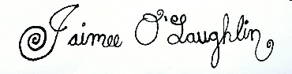

Jaimee O’Laughlin
Purchasing Agent

JO/ch

