

ADDENDUM #2
RFP #26-0093
3RD SHIFT SECURITY PERSONNEL

September 25, 2026

The following is to ensure that vendors have complete information prior to submitting a Request for Proposal. Here are some clarifications regarding the 3rd Shift Security Personnel:

Questions and/or statements of clarification are in bold font and answers to specific questions are italicized.

Please see the revised highlighted time zone below for the proposal due date.

Firms interested in submitting a Proposal, must respond with complete information and deliver on or before 1:45 pm CDT, October 6, 2026. Late responses will not be accepted and will not receive consideration for final award.

Firms interested in submitting a Proposal, must respond with complete information and deliver on or before 1:45 pm CDT, October 6, 2026. Late responses will not be accepted and will not receive consideration for final award.

“PLEASE ACKNOWLEDGE RECEIPT OF THIS ADDENDUM ON THE RFI RESPONSE PAGE.”

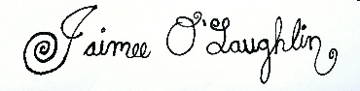

Jaimee O’Laughlin
Purchasing Agent

JO/ch

