NEONFLEX PROX-V SERIES
PROJECT:
24V DC Pixel RGBW Top Bend Neon
LOCATION:
CATALOG NUMBER:
TYPE:
Neonflex Pro APEX is the ultimate solution for achieving seamless lines of direct view lighting for any architectural-grade install. UV, flame, and saltwater resistant, Neonflex Pro APEX is not only durable, but easy to install.
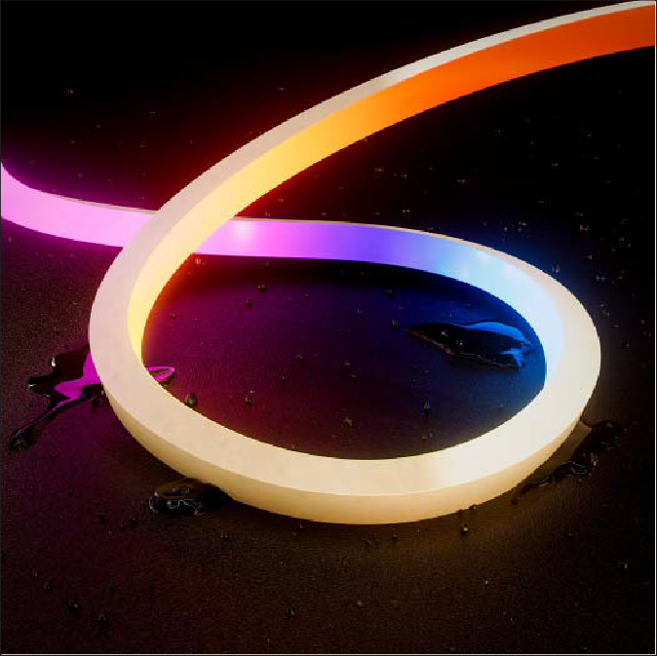
- Improved construction includes PVC backer to prevent hot-spots and enhance durability
- RGBW vertical (top bend) LED neon
- Lumen output performance up to 145Lm per foot
- Consumes up to 4.5W per foot
- Cuttable every 5" with 24ft max run
- UV, flame, and saltwater resistant
- IP67 rating featuring sealed silicone jacketing
- Dimmable (5-100%) with most OMX controls
- cULus Listed for indoor and outdoor wet locations
- 54,000 hours rated life





c@us

LISTED
NEONFLEX PROX-V PIXEL RGBW SERIES QUICK SPECS

VOLTAGE WATTAGE LUMENS CCTOPTIONS CRI

24VDC
4.5W/ft

Up to 145Lm/ft RGBW (3000K) 80+
<':24CM
i

2 PERSON INSTALLATION RECOMMENDED MINIMUM BEND RADIUS ;,24CM

CUTTING POINTS 5" (50.8mm)

MAX RUN 24ft (7.3m)

IP RATING IP67 - Jacketed

PROTOCOL DMX IC: UCS512CL

RESOLUTION 5" (127mm) pixel resolution

DIMMING DIMENSIONS

DMX
0.63" (16mm) W x 0.67" (17mm) H

Lighted Surface







¢=,
✓

BEAM ANGLE 120°

STORAGE TEMP -25°C (-13°F) to 60°C (140°F)" AMBIENT TEMP -25'C (-13°F) to 45'C (113°F)" OPERATING TEMP -25°C (-13°F) to 45°C (113'F)"
CERTIFICATIONS cULus Listed - Indoor/Outdoor Wet Location

RATED LIFE 54,000 Hours

**Do not install in inclement weather or extreme temperature conditions (i.e. -25°C (-13°F) and below). Recommended to order Custom Cut direct from American Lighting for outdoor installations.
NEONFLEX PROX-V PIXEL RGBW SERIES QUICK LOOK

36" 20 AWG Molded Connection
0.63" (16mm) W x 0.63" (17mm) H

q.. j •---�
=
28ft Max Run

NEONFLEX PROX-V SERIES CUSTOM CUT ORDERING *Custom Cut Orders - Please Allow Up To 2-4 Weeks Order Processing & Delivery*

SERIES COLOR LENGTH
�I----�

�-Pz_M_-_N_F_P_R_o_x_-v_�I
PXLRGBW = Pixel RGB+3000K
Custom Cuts: Specify desired length according to cut increment in INCHES. (See page 4 for cut increment chart). Assembly Fee per length of NeonFlex Pro-V Series Custom Cut. Custom orders are deemed Final Sale and are not able to be returned or refunded.

NEONFLEX PROX-V SERIES ASSEMBLY FEES

ITEM NUMBER
CC-LF-NFPROX-V-5-F CC-LF-NFPROX-V-5-SL
DESCRIPTION
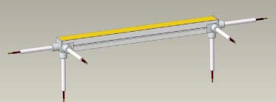
Lead: 10ft Cable Conkit, Solder, and Injection Mold Seal for Top Bend 2Pin Front Lead: 10ft Cable Conkit, Solder, and Injection Mold Seal for Top Bend 2Pin Side Left
Right Side
+ Front cable entry
FrootcabH!entry
Sioecableentry
Sidecableeotry
Bonomcableentry

CC-LF-NFPROX-V-5-SR Lead: 10ft Cable Conkit, Solder, and Injection Mold Seal for Top Bend 2Pin Side Right

CC-LF-NFPROX-V-5-B Lead: 10ft Cable Conkit, Solder, and Injection Mold Seal for Top Bend 2Pin Bottom

CC-LTF-NFPROX-V-5-F Lead & Tail: 10ft Cable Conkit, Solder, and Injection Mold Seal for Top Bend 2Pin Front

CC-LTF-NFPROX-V-5-SL Lead & Tail: 10ft Cable Conkit, Solder, and Injection Mold Seal for Top Bend 2Pin Side Left CC-LTF-NFPROX-V-5-SR Lead & Tail: 10ft Cable Conkit, Solder, and Injection Mold Seal for Top Bend 2Pin Side Right CC-LTF-NFPROX-V-5-B Lead & Tail: 10ft Cable Conkit, Solder, and Injection Mold Seal for Top Bend 2Pin Bottom CC-SETUP-NFPRO 1-9 CUT SMALL ORDER SETUP FEE FOR NFPRO
NEONFLEX PROX-V SERIES SPECIFICATION DETAILS

ITEM NUMBER | VOLTAGE | CCT | LENGTH | LUMENS / FT | WATTAGE/FT | IP RATING | CUTTING | MAX RUN
PZM-NFPROX-V-PXLRGBW-CC | 24VDC | RGB+3000K | Custom Cut | 145Lm/ft | 4.5W/ft | IP67 | 5" (50.1mm) | 24ft

NEONFLEX PROX-V SERIES ACCESSORIES

ITEM NUMBER DESCRIPTION

PZM-NFPROX-CHANG-1M NeonFlex Pro Apex 1M Aluminum Extrusion/Internal Gear

PZM-NFPROX-CHANFLEX-1M NeonFlex Pro Apex 1M Flex Stainless Steel Channel

PZM-NFPROX-CHANMl1FLEX-1M NeonFlex Pro Apex 1M Single Flange Flexible Mud-in Alumi-
num Channel

PZM-NFPROX-CHANMl2FLEX-1M NeonFlex Pro Apex 1M Double Flange Flexible Mud-in Alumi-
num Channel

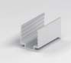
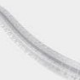
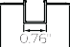
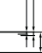
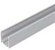
CHANG
'
0.67"
0
m
0
o_
"1
a) t-, 0
2.32"

�

CHANMl2FLEX

PZM-NFPROX-CLIPSAL PZM-NFPROX-CLIPSPC
NeonFlex Pro Apex Aluminum Mounting Clips NeonFlex Pro Apex PC Mounting Clips

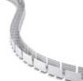
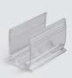
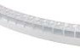
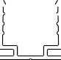
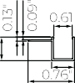
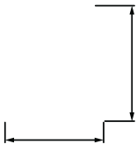
CLIPSAL CLIPSPC
CHANFLEX
CHANMl1FLEX

0.79"

i'o
t-:
0

1.54"

RECOMMENDED POWER SUPPLIES *Phase Dimming Compatible With Most MLV, ELV, and TRIAC Dimmers*

ITEM NUMBER | DESCRIPTION | MAX/ MIN LOAD | INPUT VOLTAGE | OUTPUT VOLTAGE | DIMMABLE | DIMENSIONS
PZM-DRJADPT24V-30 | Adaptive Series 30W | 30W/3W | 100-277V AC | 24V DC | Yes' | 6.49"L x 3.6"W x 1.05"H
PZM-DRJADPT24V-60 | Adaptive Series 60W | 60W/6W | 100-277V AC | 24V DC | Yes* | 7.4"L x 3.6"W x 1.05"H
PZM-DRJADPT24V-96 | Adaptive Series 96W | 96W /9.6W | 100-277V AC | 24V DC | Yes' | 8.66"L x 3.6"W x 1.61"H
PZM-DRJADPT24V-192 | Adaptive Series 192W (2 x 96W) | 192W/19.2W | 100-277V AC | 24V DC | Yes* | 10.94"L x 4.25"W x 1.B"H
PZM-DRJADPT24V-288 | Adaptive Series 288W (3 x 96W) | 288W /28.BW | 100-277V AC | 24V DC | Yes* | 11.85"L x 4.25"W x 1.8"H

