

2027 Benefit Guide
SEDGWICK COUNTY



Sedgwick County Benefits
At Sedgwick County, we know our dedicated employees—YOU—are key to our overall success as an organization.
As a way to reward you for your hard work, we provide a benefits package that is designed to help you reach your physical, financial, and mental health goals.
3 | Payroll Dates
4 | Contact Information
5 | Benefit Eligibility
6 | Benefit Enrollment
7 | Benefit Open Enrollment
8-9 | Dependent Verification
10 | New for 2027
11 | Medical/Rx Benefits
12-13 | Medical and Pharmacy Summary
14 | Medical - Surest
15 | IMARx
16 | Telehealth & Real Appeal
17 | Calm Health App
18 | Maven & Bend
19 | Where Should I Go for Care
20 | Paying for Your Healthcare
21-22 | Flexible Spending Account (FSA)
23 | Health Savings Account
24 | Dental Benefits
25 | Vision Benefits
26-27 | 2027 Premiums
28 | Life and AD&D Benefits
29-35 | Metlife Supplemental Benefits
36-37 | How to Enroll in Metlife
38 | Employee Assistance Program (EAP)
39 | Empower Retirement 457 Plan
40-44 | KPERS and KP&F
45 | Additional Benefits
46 | Helpful Information

2027 Pay Periods

Start Date | End Date | Pay Date
12/27/26 | 1/9 | 1/15
1/10 | 1/23 | 1/29
1/24 | 2/6 | 2/12
2/7 | 2/20 | 2/26
2/21 | 3/6 | 3/12
3/7 | 3/20 | 3/26
3/21 | 4/3 | 4/9
4/4 | 4/17 | 4/23
4/18 | 5/1 | 5/7
5/2 | 5/16 | 5/21
5/16 | 5/29 | 6/4
5/30 | 6/12 | 6/18
6/13 | 6/26 | 7/2
6/27 | 7/10 | 7/16
7/11 | 7/24 | 7/30
7/25 | 8/7 | 8/13
8/8 | 8/21 | 8/27
8/22 | 9/4 | 9/10
9/5 | 9/18 | 9/24
9/19 | 10/2 | 10/8
10/3 | 10/16 | 10/22
10/17 | 10/30 | 11/5
10/31 | 11/13 | 11/19
11/14 | 11/27 | 12/3
11/28 | 12/11 | 12/17
12/12 | 12/25 | 12/31

Contact Information
UHC
United Healthcare & Optum Rx
(888) 364-5089
www.myuhc.com
Surest
Empower
Optum Bank
Payroll
etimesheet@sedgwick.gov
Helpdesk
helpdesk@sedgwick.gov
Security
(316) 660-7777
Customer Service
(800) 877-7195
www.vsp.com
Surest Member Services
(866) 683-6440
www.surest.com

Surency
Flexible Spending Account
1 (866) 818-8805
www.surency.com
VSP
Delta Dental
Customer Service
(316) 264-4511
www.deltadentalks.com
Metlife Benefits
(833) 633-1430
http://account.mybenefitsportal.com/sedgwickcounty/
Amerilife
Human Resources
benefits@sedgwick.gov
Employee Assistance Program
(316) 265-9922
Crisis – (316) 660-7500
www.empac-eap.com
State of Kansas Retirement
(888) 275-5737
www.kspers.gov
Sedgwick County
KPERS/KP&F
EMPAC
Deferred Compensation 457 Retirement
(800) 701-8255
www.sedgwickcounty457.com
Health Savings Account
1 (800) 791-9361
www.surency.com

Benefit Eligibility

Your benefit plans have been designed to provide you with a package that is both comprehensive and responsive to the needs of all our employees. This booklet is designed to help you navigate your benefits choices.

Benefit Eligible Employees
If you are a benefit eligible employee, you are eligible to enroll in Sedgwick County’s benefits if you work at least 30 hours per week.

When coverage ends
If your employment with Sedgwick County terminates (voluntarily or otherwise), your benefits will end the last day of the month that you separate.
When coverage begins
You must enroll in benefits within 30 days of your date of hire. Your coverage is effective the first of the month following your enrollment.

Covering Your Family Members
Many of the plans offer coverage for your eligible family members, including:
Your legal spouse by marriage contract, your dependent children, including your stepchildren from present marriage, legally adopted children, and legal guardianship by court decree.
Dependent children are eligible for medical, dental, and vision insurance through the end of the month in which they turn age 26 (regardless of student or marital status). Married dependent children are not eligible to be covered under dependent life insurance.
Unmarried dependent children of any age may remain eligible if they are physically or mentally incapable of self-support. Dependent children over the age of 26 who are mentally or physically disabled may continue to be covered under insurance plans if they meet the following criteria:
- The disability existed before the age of 26.
- The child is incapable of self-support due to the disability.
- The child relies on the policyholder for care and support.
Contact benefits@sedgwick.gov for Disabled Dependent Applications which must be received by the insurance companies before your dependent’s 26th birthday.
No individual can be insured as both an employee and as a dependent under the medical, dental, and/or vision plan through Sedgwick County.
Dependent verification is required for all dependents added to health plans (medical, dental, and/or vision). Please see policy 4.800 for acceptable documentation to verify your dependent(s) and deadlines for submitting the required documentation.

Benefit Enrollment

Online Enrollment
From a Sedgwick County computer, open Google Chrome, go to E-line, Employee Self Service (ESS), Benefits, Benefit Enrollment, Benefits Enrollment.
After completing enrollment, please keep a copy of your email confirmation for your records.

New Employees - Initial Enrollment
Location: E-line, ESS, Benefits, Benefit Enrollment, Benefits Enrollment, Initial Enrollment
As a new employee, you must enroll in benefits through E-line within 30 days of your date of hire. If you do not enroll within 30 days, you will need to wait until the next open enrollment period to enroll. Coverage will begin the first of the month following the enrollment. Changes cannot be made after Initial Enrollment unless you have a qualifying life event.

Current Employees - Open Enrollment
Location: E-line, ESS, Benefits, Benefit Enrollment, Benefits Enrollment, Open Enrollment
Open enrollment is the only time during the year that you can change your benefits unless you experience a qualifying life event. During the open enrollment period, you can enroll in health coverage for the first time or make changes to your current plan. Open enrollment occurs every year in the Fall and coverage begins on January 1st of the following year.

Anytime Changes
Location: E-line, ESS, Benefits, Benefit Enrollment, Benefits Enrollment, Anytime Changes
Anytime changes allow changes to Health Savings Account (HSA) contributions and Advance Life and AD&D beneficiaries.

Changing Your Benefits During the Year
As stated above, you cannot change your benefits during the year unless you experience a qualifying life event. The most common qualifying life events are:
- Marriage, legal separation, or divorce.
- Birth of a child (including adoption).
- Loss of other coverage (e.g., child turns 26 and loses coverage through parent’s plan).
There are other, less common, life events that allow you to change your benefits. Please contact Human Resources for a complete list of qualifying life events.
If you experience a qualifying life event and wish to change your benefits, you must notify benefits@sedgwick.gov within 31 days of the life event. You will be required to provide proof of your life event, such as a hospital birth confirmation or marriage license. You can only change benefits that were impacted by the life event (e.g., if you get married, you can add your new spouse to the medical plan, but you cannot change medical plans).

Dependent Verification Process
Documentation, such as a birth certificate, marriage certificate, or tax document, will be required to verify that each dependent you enroll is eligible. Submit the required documentation by the enrollment deadline. Please see policy 4.800 for a list of eligible dependents and acceptable documentation along with deadlines required for verification. Documentation must be submitted to benefits@sedgwick.gov.

Remote Access
If you want to access ESS from a non-County computer, your department must submit a systems access request (SAR). Help Desk will then contact you with instructions.

Benefit Open Enrollment

Current Employees
You will need to complete your 2027 open enrollment if you plan to make plan changes, add or drop dependents, enroll in flexible spending accounts for health or dependent care, or enroll in any of the voluntary plan options.

If you do not complete open enrollment for 2027, your current benefit elections—including your enrolled dependents—will automatically continue for the 2027 plan year. However, you will not be enrolled in a Health Care or Dependent Care Flexible Spending Account (FSA) for 2027.

Recent New Hires
Employees hired October 5, 2026 – November 30, 2026 are eligible for initial enrollment only. Your initial enrollment benefit elections will carryover to 2027 except for FSA. If you want to sign up for a Flexible Spending Account (FSA) for 2027, you must email benefits@sedgwick.gov no later than November 30, 2026.

If you have questions about your benefits after reading this guide or visiting the online benefits portal, please contact Human Resources at 316-660-7050 or benefits@sedgwick.gov.

OFFERED  BENEFIT | IF YOU FAIL TO COMPLETE THE ENROLLMENT PROCESS ON OR BEFORE OCTOBER 31, 2026
Medical/Rx Plan Benefits | Your enrollment will default to what you were enrolled in for 2026: the same plans and the same dependents covered.
Dental Plan Benefits | Your enrollment will default to what you were enrolled in for 2026: the same plan and the same dependents covered.
Vision Plan Benefits | Your enrollment will default to what you were enrolled in for 2026: the same plan and the same dependents covered.
Flexible Spending Accounts (FSA) | You will not be able to contribute to a healthcare or dependent care FSA for 2027.

Dependent Verification

Dependent verification is required for all dependents added to health plans (medical, dental, and/or vision). Even though you will be able to complete enrollment, you’ll still have to complete the dependent verification process as outlined in policy 4.800 Benefits Offered by Sedgwick County. Any unverified dependents will be removed from your plan in accordance with policy 4.800.
REQUIRED DOCUMENTATION
Spousal Relationship | Documentation Required
Legal Spouse | Standard Document: Marriage certificate or marriage license (marriage license must have official seal/stamp) + (1) Joint Document  **Joint documentation is an item addressed to both parties and dated within the last 90 days. Document date must be dated within 90 days. If no document date is available, issuance date will be used.  Examples of Acceptable Joint Documentation: Utility bill, mortgage statement, auto insurance statement or your previous calendar year’s Federal Income Tax Form 1040 (showing married filing status).
Common Law Spouse | Standard Document: Sedgwick County’s Common Law Affidavit + Federal Income Tax Form 1040 showing married filing status.  Must have been established in a state that recognizes relationship.  Currently Allowed: CO, IA, KS, MT, RI, TX, DC.  Grandfathered (if est. prior to): SC (7/25/19), AL (17), PA (05), OK (98), GA (97), ID (96), OH (91).
Divorce/Legal Separation | Standard Document: Divorce decree.
Ex-Spouse | Not Eligible.
To be eligible for coverage, a dependent must reside in the United States.
Child Relationship(s) - Coverage terminates at the end of the month in which the dependent turns age 26.
The following documents will be accepted as proof of the right to carry coverage: QMCSO, MCSO, Child Support Order.
Biological/Adopted Child | Standard Document: Birth certificate, birth confirmation letter, proof of paternity, divorce decree or court document substantiating a legal adoption.
Stepchild | Standard Document: Birth certificate, birth confirmation letter, court document, proof of paternity or divorce decree and confirm eligibility of the spouse (Marriage Certificate + Joint Document).
Child Placed for Adoption | Standard Document: Dated legal documentation substantiating the placement.
Legal Guardianship | Standard Document: Court document assigning minor child under permanent legal guardianship.
Disabled Dependent  (older than 26) | Standard Document: Documentation stated above for child relationship(s) PLUS a completed Disabled Dependent Childcare Certification (contact benefits@sedgwick.gov for form). The child must be unmarried to qualify. Eligibility is determined by the benefits provider.
Grandchild | This relationship is only allowed if the member has legal guardianship over the dependent.
Foster Child | Not Eligible.
To be eligible for coverage, a dependent must reside in the United States.

Dependent Verification (Continued)
Other qualifying events
Loss of Insurance Coverage | Standard Document: Documentation stated above for type of dependents PLUS letter on company letterhead stating individuals are losing coverage and date coverage ends.
Gain of Insurance Coverage | Standard Document: Documentation stated above for type of dependents PLUS letter on company letterhead stating individuals are gaining coverage and date coverage begins.
Other | Email benefits@sedgwick.gov if you don’t see your type of dependent or your qualifying event.
ONLY if the marriage or birth took place outside of the United States.
Marriage Certificate | Documentation stated above PLUS the first page of your most recent Federal Income Tax Form – 1040 to document filing status.  *Social security numbers and financial information are to be blocked out.
Birth Certificate | Documentation stated above PLUS the first page of your most recent Federal Income Tax Form – 1040 to show claimed dependent.

Sedgwick County does not serve as a legal advisor. This information does not constitute legal advice and should not be used as a substitute for consultation with a duly licensed attorney.

Need a New Social Security Card?
Visit https://www.ssa.gov/ssnumber or call 1-800-772-1213

Need a New Birth Certificate or Marriage Certificate?
Access www.vitalchek.com any time or call 1-877-305-8315

New for 2027
New for 2027
- IMARx, Pharmacy Advocate Program offering $0 copay for eligible prescriptions.

Medical/Rx
- Premiums for all plans have increased.
- The Base Plan deductible and Out-of-Pocket Maximum increased.
- The Premier Plan name has changed to Plus Plan.
- The Plus Plan deductible and Out-of-Pocket Maximum increased.
- The High-Deductible Plan Out-of-Pocket Maximum increased, while coinsurance decreased.
- We will be adding a fourth medical plan called Surest – Copay ONLY plan.

Dental & Vision
- Delta Dental & VSP premiums have increased.

Healthcare Flexible Spending Account (FSA)
- Healthcare FSA maximum annual contribution will increase subject to IRS announcement.

Health Savings Account
- HSA maximum annual contributions will be $4,500 for single and $9,000 for family coverage.

Insurance Cards
- UHC- new cards will only be issued to new enrollees or those making plan changes. Please allow 4-6 weeks for your card(s) to arrive in the mail. If you need a temporary card, you can get one by logging into your www.myuhc.com account.
- Delta Dental- new cards will only be issued to new enrollees or those making plan changes. Please allow 4-6 weeks for your card(s) to arrive in the mail. If you need a temporary card, you can get one by logging into your Delta Dental online account.
- VSP- VSP does not issue cards. You just let your eye care provider know that you have VSP and they will look you up in their system.
- Surest – will issue new cards to all members who enroll.
- To request additional cards, contact the carrier directly.

Medical Insurance/Prescription Coverage -UnitedHealthcare (UHC)
www.myuhc.com or 888-364-5089
Group # 902769
Summary of Benefits and Coverage: https://eline.Sedgwick.gov/humanresources/benefit/benefits/forms/allitems.aspx

Sedgwick County offers four medical insurance plans through UnitedHealthcare (UHC). Please take the time to understand the features and differences of each plan so that you choose the coverage that is best for you and your family. Sedgwick County’s medical plans are self-insured which means claims are paid from your paycheck deductions and Sedgwick County’s contribution to your medical plan.
Optum RX, a subsidiary of UHC, is the administrator for the prescription plans. The prescription drug benefit utilizes the Optum RX formulary, a list of pharmaceutical drugs that are safe, medically effective, and cost effective. Please go to www.myuhc.com to find a pharmacy and prescription drug listing.
Some medications may require prior authorization or step therapy. Step therapy helps you use less expensive, but equally effective medication for certain therapeutic conditions. Most therapeutic classes have multiple medication options. You are required to initially try a Step One prescription before a Step Two prescription will be covered. If you and your provider determine the treatment is ineffective, you may request a coverage review by UHC.
All four medical plans include In- and Out-of-Network benefits, which means you can choose any provider that you would like. However, you will pay less out of your pocket when you choose a UnitedHealthcare network provider. Locate a UnitedHealthcare network provider at www.myuhc.com.
The table on the following page summarizes the key features of the medical plans. Please refer to the official plan documents for additional information on coverage and exclusions.
Transparency of Coverage: www.sedgwickcounty.org/human-resources/employee-benefits/



Medical Summary
This chart shows In-Network benefit coverage. For Out-of-Network coverage, visit www.myuhc.com.
Transparency of Coverage: www.sedgwickcounty.org/human-resources/employee-benefits/
Group #902769

 | Base PPO | Premier PPO | High Deductible (HDHP) | Surest
Deductible (Annual)  Individual  Two person/Family | $1,500  $3,000 | $1,000  $2,000 | $3,500  $7,000 | None
Out-of-Pocket Maximum  Individual  Two person/Family | $4,000  $8,000 | $2,500  $5,000 | $4,000  $8,000 | $5,000  $10,000
Pharmacy Out-of-Pocket Maximum  Individual  Two person/Family | $4,400  $8,800 | $3,000  $6,000 | N/A | N/A
Co-insurance  (Plan Pays after deductible) | 80% | 80% | 90% | N/A
Copays
Primary Care Physician  Under age 19  Over age 19 | $10  $20 | $10  $20 | 90%  (after deductible) | $10 to $65
Specialist  Tier 1 Provider  Non-Premium Provider | $20  $50 | $20  $50 | 90%  (after deductible) | $10 to $65
Urgent Care | $50 | $50 | 90%  (after deductible) | $35
Emergency Room  (copay waived if admitted) | $350 | $300 | 90%  (after deductible) | $450
Preventive Care | 100% | 100% | 100% | 100%
Hospital-Inpatient Stay  Lab, X-ray, Major Diagnostics | 80%  (after deductible) | 80%  (after deductible) | 90%  (after deductible) | Up to $2,500
Mental Health  Inpatient  Outpatient | 80%  (after deductible)  100%  (after $20 copay) | 80%  (after deductible)  100%  (after $20 copay) | 90%  (after deductible) | $10 copay  $75 copay
Maternity | 80%  (after deductible) | 80%  (after deductible) | 90%  (after deductible) | $625 to $1,600

Pharmacy Summary
 | Base PPO | Premier PPO | High Deductible (HDHP) | Surest
Retail Prescriptions  (31-day supply)  Generic  Brand  Non-Preferred Brand  Specialty | $10  $40  $70  $10, $40, $70 | $10  $40  $70  $10, $40, $70 | 90%  (after deductible) | $5  $40  $60  $200
Mail Order Prescriptions  (90-day supply through OptumRx Delivery)  Generic  Brand  Non-Preferred Brand  Specialty | $25  $100  $175  $25, $100, $175 | $25  $100  $175  $25, $100, $175 | 90%  (after deductible) | $12.50  $100.00  $150.00  $500.00
Your prescription drug benefit is included with your medical plan enrollment and is administered by Optum Rx, a pharmacy benefits manager. When you enroll in medical coverage, you will receive a Medical/Rx insurance card. You will need to present your Medical/Rx card at the pharmacy when filling prescriptions.

Most major pharmacy chains accept Optum Rx. You can save money on medications you take on a long-term basis by using mail order which allows you to get a 90-day supply for the cost of a 60-day supply.


Optum Rx

- Costco Pharmacy
- CVS Pharmacy
- Walgreens Pharmacy
- Wal-Mart Pharmacy
- Dillons Pharmacy
- Sam’s Club Pharmacy
- and many more!

Surest

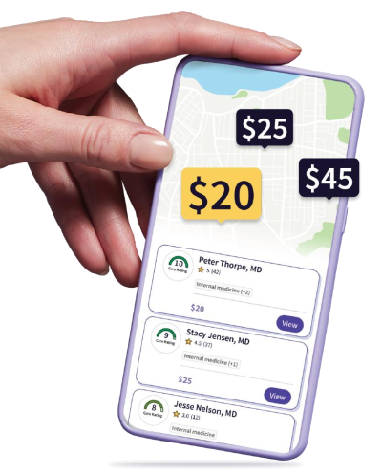
With the Surest health plan, you have the power to shop for care, then compare actual prices (not estimates) and treatment alternatives before making a decision. When checking prices in advance, you may find opportunities to save money.

In the app you can find:
- Patient-submitted ratings and reviews
  - Higher care ratings = lower copays
- Shop and find cost and coverage information before making an appointment
  - Low or no-cost virtual options available
- No deductible, no coinsurance
- Access to a dedicated member services team and clinical advocates
The Surest health plan is a no-deductible plan designed to connect you to cost and care options through an easy-to-use app. Simply search for doctors from within the large, national UnitedHealthcare network of more than 1.8 million physicians and health care professionals and more than 5,600 hospitals. View and compare copays, provider options, and other details like what’s included in a visit to help you choose care that fits your health need, lifestyle, and budget.
Common tests and x-rays that occur together are grouped into a single price (copay), which you can see before a bill arrives.
The Surest health plan includes preventive, primary and specialty visits, urgent and emergency care, hospital stays, chronic condition care, maternity care, 24/7 virtual care and prescription drug coverage.

IMARx Pharmacy Program




IMARx is a FREE program
available to you and your family members through your employer.
Enroll today and start receiving eligible medications delivered to your home at a $0.00 copay through this program benefit.
Eligible medications include specialty and high-cost brand name medications that are covered through your employer’s primary prescription insurance plan.
PHARMACY PROGRAM THAT SAVES YOU TIME AND MONEY
Once enrolled, IMA Pharmacy Advocates Program provides the following services for free:
Participation Matters
By participating in this new pharmacy benefit, you save yourself and the health plan time & money - which translates into more stable premiums over time.
Protecting Private Health Information
IMARx is separate from your employer and will not share any of your personal health information.
CALL TODAY!
IMARx (IMA Pharmacy Advocate Program) is here to answer questions and provide further assistance with enrollment completion.
Feel free to reach out to your trusted pharmacy advocate representative.
By phone: 866.530.9989 | or email: imarx@imacorp.com
+ Pharmacy Related Questions
+ Managing Medication Adherence
+ Provider Office/Patient Liaison
+ Specialty Medication Assistance
+ High-cost Brand Name Medication Assistance
PHARMACY
ADVOCATES PROGRAM

Telemedicine
Care 24/7 from your home, office, or anywhere! When you are feeling sick, the last thing you want to do is leave the house. With telemedicine, you never have to.
Telemedicine doctors can treat many common health issues, including:
- Sinus infection  - Urinary tract infection | - Skin rash  - Pink eye | - Cold and flu  - Strep throat | - Ear issues  - And many more!
Telehealth is easy to use!
- Book an appointment from anywhere, anytime at www.myuhc.com or www.surest.com, or use the UnitedHealthcare app or Surest app.
- Video chat with a board-certified doctor from your phone, tablet, or computer.
- A prescription can be sent to the pharmacy nearest you.
- Most consultations are completed in less than 20 minutes.
All four of the UnitedHealthcare medical plans include telemedicine benefits.
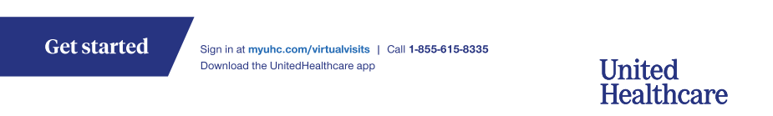


UHC Real Appeal
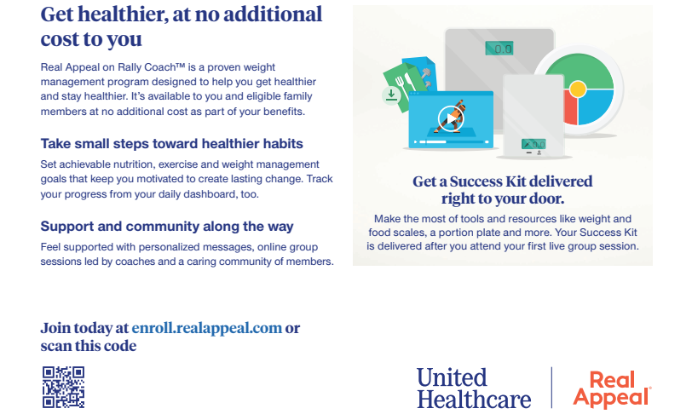

UHC Calm Health

The Calm Health app provides programs and tools to help support your mental health and well-being — all at your own pace. As a UnitedHealthcare member, Calm Health is included in your health plan and available at no additional cost.
Resources to help support your mental health
To help tailor your Calm Health experience, you’ll begin with a short mental health screening. Then, Calm Health will suggest certain programs for you to consider based on where you are in your well-being journey.
Tap into tools and support
The Calm Health app brings you a library of support — including mindfulness content and programs created by psychologists — for a variety of health experiences and life stages. This information is designed to help you:
- Learn techniques to improve well-being – Find tools, music and sounds to help
you meditate, improve focus, move mindfully and feel calm
- Work toward goals – Join self-guided self-care programs, and track your progress along the way
- Support your mind and body – Access mental health information and support to help you strengthen the mind-body connection

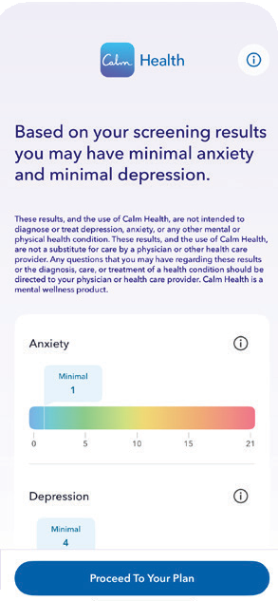
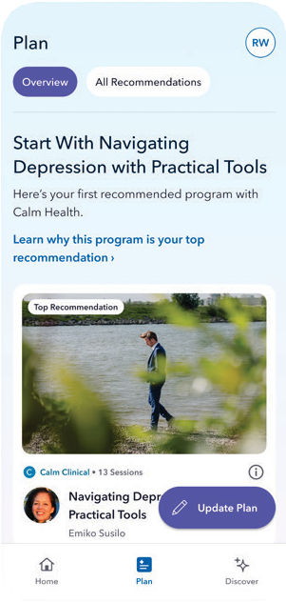
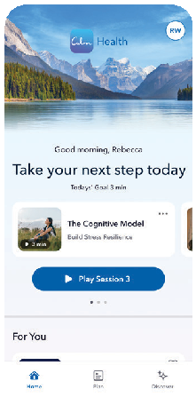



Scan this code to get started
You’ll first need to sign in to your account on myuhc.com® or the UnitedHealthcare® app. If you don’t have an account, select Register to create one.

Maven Maternity

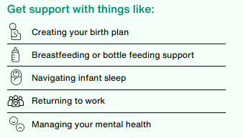
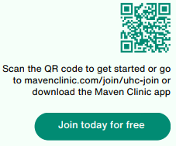

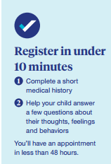
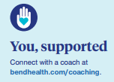
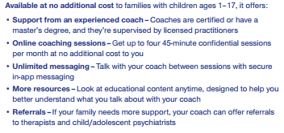



Child & Family Behavioral Health Coaching
You & your partner have free access to Maven for 24/7 pregnancy and postpartum support and guidance-all in one app.

Where Should I Go For CARE?
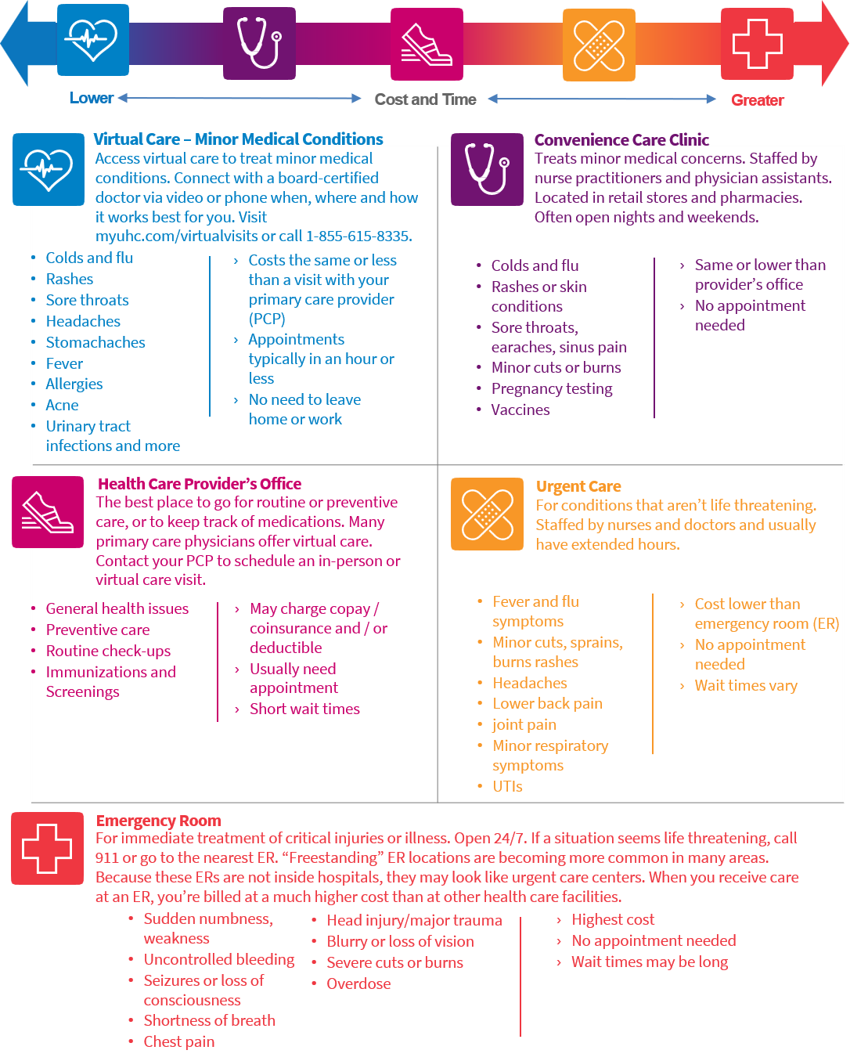
Seeking care at an appropriate place of treatment can help you save money and time.
Use the chart to help guide you to the most time and cost-effective place of treatment.

Paying for Your Healthcare Costs

Sedgwick County offers accounts that allow you to save on your out-of-pocket healthcare costs on a pre-tax basis.
Health SAVINGS account versus Flexible SPENDING account: Which is right for you?

 | HSA | FSA | Dependent Care FSA
Eligible plan members | HDHP members only | Non HDHP members only | All Benefit Eligible Employees
Money is available | Deposited each pay period | 1st day of plan’s effective date | Deposited each pay period
Annual 2027 contribution limits | Single medical coverage:  2027 - $4,500  2-person/Family medical coverage:  2027 - $9,000  Over 55 - $1,000  catch up | $3,400 (subject to IRS announcement) | $7,500 (subject to IRS announcement and IRS regulations)
Spending deadline | None | March 15, 2028 | March 15, 2028
Rollover | Full amounts rollover every year | No rollover | No rollover
Option to invest and grow money | Yes | No | No
Eligible expenses | Medical/RX, Dental & Vision | Medical/RX, Dental &  Vision | Daycare Expenses
Must keep receipts | Yes, keep receipts for IRS audits | Yes, keep for substantiation | Yes, keep for substantiation
Must re-enroll each year | No, but can make anytime changes | Yes, must enroll during open enrollment | Yes, must enroll during open enrollment
Monthly Fee | $2.00 | No | No

Flexible Spending Account (FSA)-Surency
www.surency.com or 866-818-8805

Sedgwick County offers two flexible spending account (FSA) options through Surency. The money that you put into an FSA is collected from your paycheck before taxes are withheld, which means you don’t pay taxes on those dollars. FSAs annual contribution amounts cannot be changed. Contributions are prorated (i.e. annual contribution amount is divided by remaining deductions for that year). You must re-enroll in FSA every open enrollment; it does not renew automatically. A few very important rules apply to FSAs. Please read this page carefully before you make your FSA elections!
- You may incur expenses through March 15, 2028.
- You must file claims or submit receipts by May 14, 2028.
- Any funds left in the account as of May 15, 2028 are forfeited.
- You are required to submit itemized receipts to substantiate your qualified expenses to Surency even if you’re using the debit card or submitting reimbursement. If you do not supply substantiation, you will be required to reimburse the plan or be subject to taxation per IRS regulations.
- If you receive employer contributions, they are subject to the same substantiation and taxation as employee contributions (see previous bullet).
- A full list of eligible expenses is available at www.irs.gov.publications/p502.

Health Care FSA
- You can contribute to the Health Care FSA if you are:
‒ enrolled in Sedgwick County’s Base Plan, Plus Plan or Surest Plan, OR
‒ not enrolled on the County’s medical insurance AND not covered under another High Deductible Health
Plan.
- Health Care FSA funds can be used to pay for eligible Out-of-Pocket expenses such as deductibles, copays, and other health related expenses that are not reimbursed by the medical, dental, or vision plans.
- You may contribute $50 - $3,400 (subject to the 2027 IRS announcement) to your Health Care FSA for the 2027 calendar year. The entire amount you elect is available to you on January 1, 2027 or your benefits effective date.
- You can also make FSA purchases at the FSAStore at www.fsastore.com.
Dependent Care FSA
- You can contribute to the Dependent Care FSA regardless of the plan you are enrolled in OR even if not enrolled on the County’s medical insurance.
- Dependent Care FSA funds can be used to pay for eligible dependent care expenses that allow you and your spouse to work or attend school full time.
- Eligible expenses include day care, preschool, summer camp, before and after school care, and elder care.
- Funds can be used for care for your: Children under 13 years of age; children over 13, spouse, and/or elderly parent who lives with you and is unable to care for themselves.
- You may contribute $50-$7,500 (subject to the 2027 IRS announcement) to the Dependent Care FSA for the 2027 calendar year if you are married and file a joint return OR if you file a single OR head of household return.
- Funds are only available in the amount you have accrued in your account balance.
- You must incur expenses through March 15, 2028.
- You must file claims or submit receipts by May 14, 2028.
- Any funds left in the account as of May 15, 2028 are forfeited.

Flexible Spending Account
Surency is our flexible spending accounts administrator. Flexible spending accounts (FSAs) allow you to pay for eligible health care and dependent care expenses using tax-free dollars. Putting money into an FSA before you pay taxes on it saves you money by lowering your taxable income. You must re-enroll in FSA(s) every year during open enrollment if you wish to participate.
There are two types of FSAs:

Health Care FSA | Dependent Daycare FSA
Used to pay for out-of-pocket expenses not covered by your medical, prescription, dental, or vision plan such as copays, coinsurance, and deductibles. Your full annual election is available for use on day 1 of your benefit effective date. A flex debit card will be provided for you to use for covered expenses, or you can pay by another method and submit a claim form to Surency for reimbursement. You do not have to be enrolled in the County’s health plan to participate. | Used to pay child care expenses for children under age 13, or a disabled tax dependent. You can only seek reimbursement from the funds you have contributed. A flex card is not available for this account. You must pay for the child care expenses then submit a claim to Surency for reimbursement.
Maximum amount you can contribute annually is $3,400 (subject to IRS 2027 announcement). | Maximum amount you can contribute annually is $7,500 per household for single filers or married couples filing jointly, and $3,750 for married couples filing separately.
FSA Frequently Asked Questions
Do I need to keep any records when I use my FSA?
To be compliant with the IRS guidelines, your FSA administrator may ask for an itemized receipt or Explanation of Benefits to substantiate claims.
When do I have access to my FSA funds?
For the healthcare flex, your annual election is available on the effective date of your plan. The election amount will be contributed through even payroll deductions throughout the plan year. For dependent care flex, only the funds you have contributed to date through payroll deduction are available.
What if I do not use all of the FSA money by the end of the calendar year?
FSA funds abide by the “use-it-or-lose it” rule. All unused Health Care FSA funds not submitted by the filing deadline, will be forfeited to the plan. For the Dependent Care FSA, any balance not used by the deadline will be forfeited. The filing deadline is May 14th of the following calendar year.
What if I separate employment with Sedgwick County?
Your FSA card will be deactivated on your last day of employment. You will have until the end of the month that you separate to incur expenses. Manual claims must be submitted and must be done within 60 days from the last day of the month you separate. If you have spent more than you contributed, you will not owe any money back, but those claims must be substantiated.
Can I participate in a Healthcare Flex account if I or my spouse contribute to a Health Savings Account (HSA)?
No, you cannot participate in the Health Care FSA if you are eligible and contributing to a Health Savings Account (HSA).

Health Savings Account (HSA) - Optum Bank
www.optumbank.com or 800-791-9361

A health savings account (HSA) is a bank account that allows you to save, spend, and invest your money on a pre-tax basis. You must enroll in the UnitedHealthcare High Deductible Health Plan (HDHP) in order to contribute to an HSA. HSA contributions can be changed anytime throughout the year by going to E-line, ESS, Benefits, Benefit Enrollment, Benefits Enrollment, Anytime Changes. You can use your HSA for qualifying medical, dental, and vision expenses.
You don’t pay taxes on the money you contribute to your HSA from your paycheck.
Use the HSA contribution calculator at www.optumbank.com and check out the Optum Store for additional information and HSA eligible products.
- If you enroll in the UnitedHealthcare High Deductible Health Plan (HDHP), you agree to have a Health Savings Account (HSA) established in your name with Optum Bank regardless of if you contribute to the account or not at the time of enrollment. If you decide not to contribute, you must enroll with a $0.00 contribution.
- A $2.00 monthly fee will be deducted from your balance.
- When you set up an HSA, it is important that you select a beneficiary. This will ensure that your HSA money is immediately available to your beneficiary upon your death. If you don’t select a beneficiary, the money will go to your estate and may be subject to taxation.
- You do not have to send receipts to Optum Bank to verify eligible expenses. If you are audited by the IRS, you’ll need to provide documentation showing you have had eligible health care expenses to cover any withdrawal from your HSA. Keep all health care receipts.

Contribute up to the IRS limits
Contributions to an HSA, including your annual exam attestation incentive and/or vacation sold to your HSA, cannot exceed the annual IRS contribution limits. IRS rules state that contribution limits must be prorated by the number of months you are eligible to contribute to an HSA. If you don’t have an HDHP/HSA for a full year, use the chart to determine your prorated contribution limit for the time you had an HDHP/HSA. Calculate how many months you’ll have an HDHP/HSA for the plan year and find that number in the number of months column; that is how much you can contribute without getting a possible IRS tax penalty. For more information on prorated contribution limits, contact Optum Bank.
The 2027 IRS maximum contributions are:
Single coverage: $4,500.
Two person/Family coverage: $9,000.
Employees ages 55+ by December 31, 2027 may contribute an additional $1,000 catch-up contribution to their HSA.
HSA Eligibility Rules
You cannot be covered by another non-HSA-eligible medical plan. You cannot be claimed as a dependent on someone else’s tax return. You cannot be enrolled in Medicare, TRICARE, or TRICARE for Life.
Additional rules apply. Please see IRS Publication 969 for more information www.irs.gov/publications/p969.
Number of Months | Single | Family | Catch-Up (Age 55+ only)
12 months | $4,500 | $9,000 | $1,000
11 months | $4,125 | $8,250 | $916
10 months | $3,750 | $7,500 | $833
9 months | $3,375 | $6,750 | $750
8 months | $3,000 | $6,000 | $666
7 months | $2,625 | $5,250 | $583
6 months | $2,250 | $4,500 | $500
5 months | $1,875 | $3,750 | $416
4 months | $1,500 | $3,000 | $333
3 months | $1,125 | $2,250 | $250
2 months | $750 | $1,500 | $166
1 month | $375 | $750 | $83

Dental Insurance - Delta Dental
www.deltadentalks.com or 316-264-4511
Group #90192
Summary of Benefits and Coverage: https://eline.sedgwick.gov/humanresources/benefit/benefits/forms/allitems.aspx

There are no deductibles under the Delta Dental Plan for any eligible expenses. You can choose any dentist that you would like, however you will pay less out of your pocket when you choose an In-Network dentist. Locate a Delta Dental In-Network dentist at www.deltadentalks.com.
The table below summarizes the key features of the dental plans. The co-insurance amounts listed reflect the amount you pay for services. Please refer to the official plan document for additional information on coverage and exclusions.

 | In-Network
Annual Benefit Maximum  (per covered individual) | $1,000
Diagnostic/Preventive Services  (will not count towards the $1,000 annual maximum)  (i.e. cleanings, sealants) | 100%
Basic Services  (i.e. fillings, root canals) | 80%*
Major Services  (i.e bridges, crowns) | 50%
Orthodontics  ($1,500 lifetime maximum per covered individual) | 50%

Two cleanings are covered each year per covered individual and there is no requirement to wait exactly six months between visits.
*If you do not have at least one cleaning in the past 12 months, basic services reduce to 50%.

Only your covered basic and major services will count towards the $1,000 annual maximum. Your diagnostic and preventive services will not count towards the $1,000 maximum. This means that even if you reach your annual maximum throughout the plan year from basic and major services, you will still have coverage for your diagnostic and preventive services.

Vision Insurance - Vision Service Plan (VSP)
www.vsp.com or 833-633-1430
Group #30078063
Summary of Benefits and Coverage
https://eline.sedgwick.gov/humanresources/benefit/benefits/forms/allitems.aspx

Sedgwick County offers a vision insurance plan through Vision Service Plan (VSP). This plan allows you to choose any eye care provider. However, you will maximize the plan benefits when you choose an In-Network provider. Locate a VSP network provider at www.vsp.com.

 | Max Plan Pays | Co-pay | Frequency
Eye Exam |  | $10 | Every calendar year
Frames | $180 | $0 | Every other calendar year
Eye Glass Lenses | $160 | $0 | Every calendar year
Contacts  (in lieu of eye glass lenses)  Contact lens exam | $160 | $0  $40 | Every calendar year
Diabetic Eye Care Plus Program* | $20 | $0 | As needed
*Services related to diabetic eye disease, glaucoma, and age-related macular degeneration. Retinal screening for eligible members with diabetes. Limitations and coordination with medical coverage may apply.

You may select either contact lenses or eyeglasses during the same plan year, but not both.

KidsCare Program

This benefit is included in your vision plan. Enrolled dependent children under the age of 18 can receive two comprehensive eye exams and one new pair of frames and lenses every calendar year.

2027 Premiums
Premiums are deducted on the first two paychecks of each month.
Medical
Base PPO
 | Total Cost | Employer Cost* | Employee Cost
Employee Only | $424.45 | $382.29 | $42.16
Employee + Spouse | $932.77 | $840.05 | $92.72
Employee + Children | $761.28 | $688.41 | $75.87
Family | $1,272.32 | $1,145.91 | $126.41
Plus PPO
 | Total Cost | Employer Cost* | Employee Cost
Employee Only | $445.63 | $379.21 | $66.42
Employee + Spouse | $979.19 | $833.16 | $146.03
Employee + Children | $802.26 | $682.77 | $119.49
Family | $1,335.62 | $1,136.51 | $199.11

High-Deductible Health Plan (HDHP)

High-Deductible Health Plan (HDHP)
 | Total Cost | Employer Cost* | Employee Cost
Employee Only | $390.99 | $371.59 | $19.40
Employee + Spouse | $859.18 | $816.50 | $42.68
Employee + Children | $704.06 | $669.14 | $34.92
Family | $1,171.96 | $1,113.78 | $58.18

High-Deductible Health Plan (HDHP)
Surest
 | Total Cost | Employer Cost* | Employee Cost
Employee Only | $436.01 | $436.01 | $0
Employee + Spouse | $949.65 | $902.45 | $47.20
Employee + Children | $779.39 | $740.70 | $38.69
Family | $1,292.75 | $1,228.52 | $64.23
*Includes employer surcharge.
Single $2.84, Employee + Spouse & Employee + Children $5.68, Family $8.24

Please note the changes in rates effective 1/1/2027 for medical, dental, and vision.

2027 Premiums Continued
Premiums are deducted on the first two paychecks of each month.
Dental
 | Total Cost | Employer Cost | Employee Cost
Employee Only | $17.54 | $14.03 | $3.51
2-Person | $35.07 | $28.05 | $7.02
Family | $50.94 | $40.68 | $10.26
 | Total Cost | Employer Cost | Employee Cost
Employee Only | $3.94 | $0.00 | $3.94
2-Person | $7.88 | $0.00 | $7.88
Family | $12.86 | $0.00 | $12.68
Please note the changes in rates effective 1/1/2027 for medical, dental, and vision.
Vision

Advance Life, Accidental Death and Dismemberment (AD&D)

Advance Life and Accidental Death and Dismemberment (AD&D) insurance provides financial protection for those who depend on you for financial support. Upon your death, your designated beneficiary(ies) will receive the life benefit. If you die as the result of an accident, your beneficiary(ies) will receive both the life and AD&D benefits.
Sedgwick County provides you with $50,000 life and AD&D at no cost to you.
You can purchase optional voluntary life and AD&D. Deductions will come out of the first two paychecks of each month. *The amounts below include the $50,000 provided by Sedgwick County.
Advance Life and AD&D
$75,000 | $2.25
$100,000 | $4.50
$125,000 | $6.75
$150,000 | $9.00
Dependent Life: Dependent life insurance is for a legal spouse and/or unmarried children under the age of 26. Dependent life insurance coverage ends when the employee reaches age 75. Deductions will come out of the first two paychecks of each month.
Dependent Life
$5,000 Spouse and Child(ren) | $0.82
$10,000 Spouse only | $0.65
$10,000 Child(ren) only | $1.00
$10,000 Spouse and Child(ren) | $1.65
Rates are subject to change due to Advance underwriting.
*Federal laws state that life insurance amounts in excess of $50,000 are taxable and is added to your W-2. These amounts are called imputed income.
Keeping your beneficiary designations up to date is vital for ensuring your life insurance benefits go the right people. Naming a minor child as a beneficiary can slow down payments because a court will need to appoint a guardian to manage the funds.
Reviewing your beneficiary designations during open enrollment every year will help keep them accurate.



Supplemental Benefits – AmeriLife/Benefits Direct
https://mybenefitsportal.com/sedgwickcounty/ or 833-633-1430
Group #238768
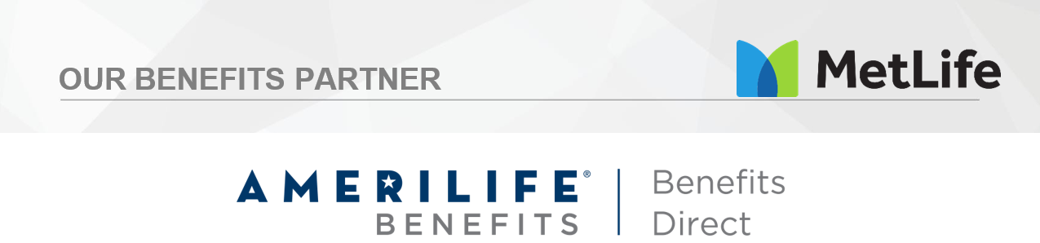

Amerilife Benefits is proud to partner with Sedgwick County Government and Metlife to help communicate and educate employees on the Metlife supplemental plans made available to all benefit eligible employees.
Our mission is to provide you the employee with useful tools and help educate you about your employee benefits. Keep in mind when you speak to a benefits representative on our team, they are non-commissioned. We are here to educate you on your options, not sell you something.
Contact us today if we can help you in any way with your employee benefit needs at Sedgwick County!
For help or assistance, we are always just a phone call or email away!
Telephone: 833-633-1430
Email: customersupport@amerilifebenefits.com
Website: https://mybenefitsportal.com/sedgwickcounty/
The information in this Enrollment Guide is presented for illustrative purposes and is based on information provided by the employer. The text contained in this guide was taken from various summary plan descriptions and benefit information. While every effort was taken to accurately report your benefits, discrepancies or errors are always possible. In case of discrepancy between the guide and actual plan documents, the actual plan documents will prevail. All information is confidential, pursuant to the Health Insurance Portability and Accountability Act of 1996. If you have any questions about the guide, please contact HR.

Supplemental Benefits – AmeriLife/Benefits Direct
https://mybenefitsportal.com/sedgwickcounty/ or 833-633-1430
Group #238768
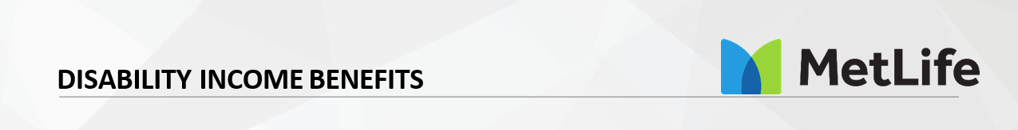

Eligibility: All active, full-time employees
At Sedgwick County, we want to do everything we can to protect you and your family. Sedgwick County provides employees with voluntary short-term disability income benefit plan options. Without disability coverage, you and your family may struggle to get by if you miss work due to an injury or illness.
In the event that you become disabled from a non-work-related injury or sickness, disability income benefits will provide a partial replacement of lost income. Please note, though, that you are not eligible to receive disability benefits if you are receiving workers’ compensation benefits.

 | Plan Option 1
Benefits Begin | For injury & sickness: 15th day
Benefit Amounts Available | You may elect a monthly benefit in increments of $25 from a minimum of $50, up to a maximum benefit of $1,000
Maximum Benefit | Your elected monthly benefit amount may not exceed 60% of your covered salary and will pay a maximum of 24 weeks.

Your monthly employee rates are outlined below:
Issue Age | Rate per $10 of weekly covered benefit
Less than 50 | $1.24
50 to 59 | $2.22
60+ | $3.01

Supplemental Benefits – AmeriLife/Benefits Direct
https://mybenefitsportal.com/sedgwickcounty/ or 833-633-1430
Group #238768


Accidents can happen to anyone, anywhere, at any time! Paying for out-of-pocket medical costs or other indirect costs after an accidental injury can be stressful. That's why Sedgwick County offers a voluntary accident insurance plan that allows you to elect coverage for either yourself or the entire family.
Accident insurance helps pay for the unexpected costs of an accidental injury by providing you cash benefits for things such as initial care, specific injuries, treatment, facility care, and follow-up care visits. Any of the benefits you receive from the policy are paid directly to you and can help you cover deductibles, co-insurance, or whatever expenses you may choose to spend it on.
 | Low Plan Benefits | High Plan Benefits
Fracture | $100 - $8,000 | $200 - $10,000
Dislocation | $100 - $8,000 | $200 - $10,000
Second- or Third-Degree Burns | $75 - $10,000 | $100 - $15,000
Concussion | $250 | $500
Coma | $7,500 | $10,000
Laceration | $50 - $400 | $75 - $700
Ambulance | Ground: $300/ Air: $1,000 | Ground: $400/ Air: $1,250
ER care | $75 - $150 | $100 - $1,000
Non-Emergency Initial Care | $75 | $100
Physician Follow-Up | $75 | $100
Therapy Services | $35 | $50
Medical Testing | $150 | $200
Transportation | $300 | $400
Medical Appliances | $75 - $750 | $150 - $1,000
Transportation | $300 | $400
Accidental Death Benefits | Basic Accidental  Employee $25,000 Spouse $12,500 Child $5,000 | Basic Accidental  Employee $50,000 Spouse $25,000 Child $10,000
Accidental Dismemberment, Loss & Paralysis | Between $750 - $20,000 | Between $1,000 - $40,000
*Not full list of coverage. For full list, go to E-line, ESS, Benefits, MetLife, Benefit Details, Accident Coverage.
Your monthly employee rates are outlined below:
 | Low Plan Cost | High Plan Cost
Employee | $11.80 | $15.84
Employee & Spouse | $23.39 | $31.26
Employee & Child(ren) | $28.05 | $37.43
Employee & Spouse/Child(ren) | $33.19 | $44.28

Supplemental Benefits – AmeriLife/Benefits Direct
https://mybenefitsportal.com/sedgwickcounty/ or 833-633-1430

Group #238768

Most of us are not financially prepared for a medical crisis caused by a cancer diagnosis within our family. Out-of-pocket expenses can deplete our savings, home equity and retirement funds. Major medical insurance does not cover many non-medical expenses.
No one wants to experience a cancer diagnosis, but the fact is that the risk of getting cancer is great. In the United States, men have slightly less than a one in two lifetime risk of developing cancer; for women, the risk is a little more than one in three (Cancer Facts and Figures 2012, American Cancer Society). Your plan pays a lump-sum Initial Benefit upon the first verified diagnosis of a covered cancer. Your plan also pays a lump-sum Recurrence Benefit for a subsequent verified diagnosis of the same cancer as shown in the table below. A Recurrence Benefit is only available if an Initial Benefit has been paid for the same cancer.

 | Benefit Amount | Initial Benefit | Recurrence Benefit
Employee | $15,000 - $30,000 | Invasive Cancer: 100% of benefit amount  Non-Invasive Cancer: 25% of Benefit Amount  Skin Cancer: 5% of benefit amount | Invasive Cancer: 100% of initial benefit amount Non-Invasive Cancer: 100% of initial benefit  amount  Skin Cancer: None
Spouse | 50% of employee’s initial benefit
Dependent Children | 50% of employee’s initial benefit

Your monthly employee rates per $1,000 of Coverage are outlined below:
Issue Age | EO | ES | EC | Family
<25 | $0.32 | $0.53 | $0.46 | $0.66
25 – 29 | $0.39 | $0.63 | $0.52 | $0.76
30 – 34 | $0.48 | $0.77 | $0.62 | $0.90
35 – 39 | $0.62 | $0.97 | $0.75 | $1.11
40 – 44 | $0.88 | $1.36 | $1.01 | $1.49
45 – 49 | $1.16 | $1.78 | $1.29 | $1.92
50 – 54 | $1.51 | $2.32 | $1.64 | $2.45
55 – 59 | $1.88 | $2.88 | $2.01 | $3.01
60 – 64 | $2.22 | $3.39 | $2.35 | $3.52
65 – 69 | $2.28 | $3.49 | $2.42 | $3.63
70 – 74 | $2.00 | $3.06 | $2.13 | $3.20
75+ | $2.17 | $3.33 | $2.31 | $3.47

Supplemental Benefits – AmeriLife/Benefits Direct
https://mybenefitsportal.com/sedgwickcounty/ or 833-633-1430
Group #238768


Most of us are not financially prepared for a medical crisis caused by a critical illness diagnosis within our family. Out-of-pocket expenses can deplete our savings, home equity and retirement funds. Major medical insurance does not cover many non-medical expenses.
Your plan pays a lump-sum Initial Benefit upon the first verified diagnosis of a covered critical illness. Covered critical illnesses include cancer, heart attack, stroke, Alzheimer’s, ALS & Parkinson’s. Your plan also pays a lump-sum Recurrence Benefit for certain covered illness shown below.
 | Employee | Spouse & Dependent Children
Benefit Amounts | $15,000 - $30,000 | 50% of employee’s initial benefit
Covered Diseases | Initial Benefit | Recurrence Benefit
Benign Brain Tumor | 100% of Benefit Amount | 100% of Initial Benefit Amount
Invasive | 100% of Benefit Amount | 100% of Initial Benefit Amount
Non-Invasive Cancer | 25% of Benefit Amount | 100% of Initial Benefit Amount
Skin Cancer | 5% of Benefit Amount | None
Coronary Artery Bypass | 50% of Benefit Amount | 100% of Initial Benefit Amount
Childhood Disease (Cerebral Palsy, Cystic Fibrosis, Diabetes, Down Syndrome, Sickle Cell Anemia & Spina Bifida) | 100% of Benefit Amount | None
Coma | 100% of Benefit Amount | 100% of Initial Benefit Amount
Functional Loss Category Loss of speech, hearing, sight, paralysis of 2 or more limbs) | 100% of Benefit Amount | None
Heart Attack | 100% of Benefit Amount | 100% of Initial Benefit Amount
Sudden Cardiac Arrest | 100% of Benefit Amount | None
Infectious Disease Category (Bacterial Cerebrospinal Meningitis, Diphtheria, etc.) |  | None
Kidney Failure | 100% of Benefit Amount | None
Major Organ Transplant Category (Heart, Lung, Marrow, etc.) | 100% of Benefit Amount | None
Progressive Disease Category (ALS, Alzheimer’s, Parkinson’s, etc.) | 100% of Benefit Amount | None
Severe Burn | 100% of Benefit Amount | 100% of Initial Benefit Amount
Stroke | 100% of Benefit Amount | 100% of Initial Benefit Amount

Your monthly employee rates per $1,000 of Coverage are outlined below:
Issue Age |  | <25 | 25-29 | 30-34 | 35-39 | 40-44 | 45-49 | 50-54 | 55-59 | 60-64 | 65-69 | 70-74 | 75+
Plan Type | EO | $0.50 | $0.63 | $0.81 | $1.07 | $1.56 | $2.10 | $2.78 | $3.52 | $4.30 | $4.64 | $4.53 | $5.78
Plan Type | ES | $0.79 | $0.98 | $1.26 | $1.65 | $2.39 | $3.20 | $4.23 | $5.36 | $6.54 | $7.05 | $6.88 | $8.75
Plan Type | EC | $0.67 | $0.80 | $0.98 | $1.24 | $1.73 | $2.27 | $2.95 | $3.69 | $4.47 | $4.81 | $4.70 | $5.95
Plan Type | FAM | $0.96 | $1.15 | $1.43 | $1.82 | $2.56 | $3.37 | $4.40 | $5.53 | $6.71 | $7.22 | $7.05 | $8.92

Supplemental Benefits – AmeriLife/Benefits Direct
https://mybenefitsportal.com/sedgwickcounty/ or 833-633-1430
Group #238768
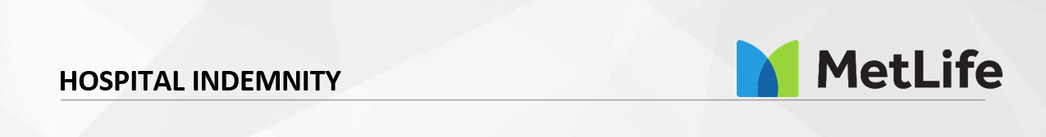

Focus on recovery during a hospital stay ─ not your out-of-pocket costs. A hospital confinement due to an illness or injury can happen to anyone. Chances are when it occurs you will have unplanned expenses to pay. Will you be prepared? Hospital Indemnity insurance benefit payments are made directly to you, no matter what other coverage you may have, and can be used however you choose.
These benefit payments can help pay for out-of-pocked healthcare costs or other household expenses which can pile up during a hospital stay. Hospital Indemnity insurance helps provide financial peace of mind.
 | Low Plan | High Plan
Admission (4 times a year) ICU Supplemental Admission | $500  $500 | $1,000  $1,000
Confinement Benefit (15 days per year) ICU Supplemental Confinement | $100  $100 | $200  $200
Newborn confinement (2 days per confinement) | $25 | $50

Your monthly employee rates are outlined below:

 | Low Plan Cost | High Plan Cost
Employee | $10.47 | $20.72
Employee & Spouse | $21.93 | $43.43
Employee & Child(ren) | $16.67 | $33.02
Employee & Spouse/Child(ren) | $28.14 | $55.72

Supplemental Benefits – AmeriLife/Benefits Direct
https://mybenefitsportal.com/sedgwickcounty/ or 833-633-1430
Group #238768


Pets are a critical part of many employees’ and their families’ lives. They can provide much needed comfort and even make sure we get our daily exercise. But, if they get sick or have an accident and need veterinary care, the cost of potential life-savings procedures can be significant.
Sedgwick County provides a voluntary pet protection insurance option to help cover the cost of care and get you and your pet back on track.
Contact MetLife for a no obligation quote, and reference Sedgwick County for our discounted rates with savings up to This coverage can be purchased at any time through direct billing — no payroll deduction is available.
Phone Number: 1-800-GET-MET8
Website for a quote: https://www.Metlife.com/getpetquote


MetLife Enrollment

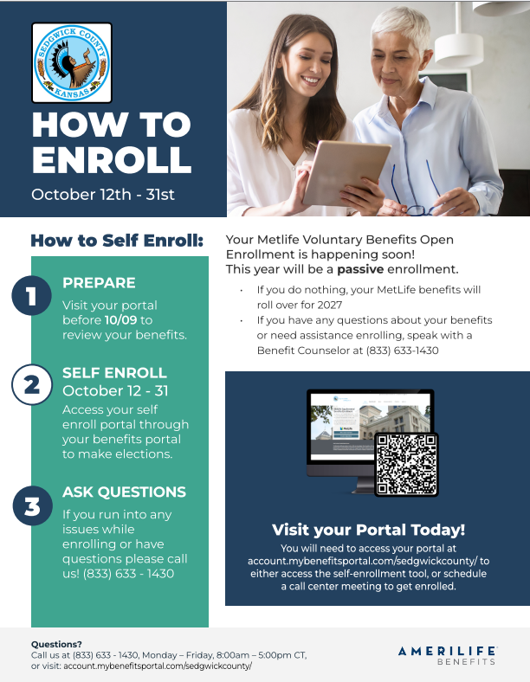

MetLife Enrollment


Employee Assistance Program (EMPAC)


Mental Wellness Support
Sedgwick County

When you or a household member need trusted, professional help, empac is just a phone call away. For more than 40 years, empac has been helping employees thrive in their personal and professional lives by providing caring and compassionate support.

Free, confidential, empac services include:
12 phone, video, or in-person sessions per household per year for personal and professional needs such as:
- Stress, depression, anxiety
- Family and parenting concerns
- Marital and relationship challenges
- Workplace conflicts
- Alcohol or drug dependency
- Grief and loss

WorkLife Services
- Financial consultation and resources for debt management and consolidation, identity theft, budgeting, and credit report information.
- Legal consultation with an attorney for issues relating to family law, estate planning, traffic citations, landlord conflicts, and many others. Discounted legal fees.
- Dependent care resources and referrals.
- Elder care resources and referrals.
- Self-help resources on a variety of topics via a member only website.
- Monthly newsletters for employees and supervisors.

Who can use this benefit?
All Sedgwick County employees AND everyone living in their household are eligible for these services.

Get started. Make your free appointment.
☎ 316.265.9922 | ☎ 800.234.0630 | txt 316.710.7374 | empac-eap.com
200 W. Douglas, Suite 250, Wichita, KS 67202

Deferred Compensation Plan 457-Empower
Jon Horning Retirement Plan Advisor: 316-350-6957 or jon.horning@empower.com https://jon_horning.empowermytime.com/

Participant Services: 1-800-701-8255

Sedgwick County provides a 457 plan to benefit eligible employees who may contribute portions of their salary into the plan. Employees can choose to make contributions on either a pre-tax or post-tax basis. If they choose the latter, the account compounds tax-free, essentially the same as a Roth IRA. If they opt for the pre-tax contributions, the plan money is not taxed until the employee withdraws the money.
Your Retirement Plan Advisor is available to provide you one-on-one counseling with personalized account services at no cost to you, such as:
- Enrollment
- Contributions
- Retirement readiness
- Investment choices
- Account review
- Comparison of retirement plans
- Rollovers - Consider all your options and their features and fees before moving money between accounts.
New Employees
Sedgwick County 457 Deferred Compensation Plan Automatic Enrollment Notice
All newly hired benefit eligible employees will be automatically enrolled in the Sedgwick County 457 Plan. 1% of your gross pay will be deducted from your paycheck automatically each pay period and contributed to the Plan. Automatic deduction will increase by 1% automatically each year until a total of 6% is reached.
You will not see the 1% deduction from your paycheck for about 4-6 weeks. If you wish to contribute more than the 1%, you may elect to do so. If you do not want the automatic deduction, you must opt out within 30 days of the date of the PIN letter you receive from Empower. If you do not opt out prior to this date, your first automatic deduction will be made.



KPERS
Kansas Public Employees Retirement System (KPERS) Pension Plan
All Sedgwick County employees who work in KPERS or KP&F covered positions are members of the Kansas Public Employees Retirement System (KPERS), as required by state law. As an active member, you contribute a percentage of your gross earnings to your KPERS retirement account. Once vested with KPERS, you are guaranteed a lifetime retirement benefit.

The KPERS website has valuable information regarding your KPERS membership including links to KPERS publications, forms, and access to your Member Account. From your Member Account, you can review your KPERS benefits, access your Member Annual Statement, and utilize the online Retirement Estimate Calculator. To get the best possible estimate results, have your latest KPERS Annual Statement available to enter years of service and salary information.

For more information go to www.kspers.gov.

KPERS 3
Benefits Members hired January 1, 2015 and after Contribution Amount: As a KPERS 3 member,
you contribute 6% of your income.
Earning Interest: Your contributions earn 4% interest annually (1% quarterly). There is also a possibility of additional interest, depending on KPER’s investment returns.

Your Retirement Credits
You earn retirement credits while working. They are based on a percentage of your pay and the number of years you’ve
worked. You receive these credits quarterly and your annual credit rate increases the longer you work. They can only be used at retirement.

KPERS 1
Benefits Members hired before July 1, 2009
Contribution Amount: As a KPERS 1 member, you contribute 6% of your income
Earning Interest: If you became a member before July 1, 1993, your contributions earn 7.75% interest. On or after July 1, 1993, your contributions earn 4% interest.

KPERS 2
Benefits Members hired July 1, 2009, through December 31, 2014
Contribution Amount: As a KPERS 2 member, you contribute 6% of your income.
Earning Interest: Your contributions earn 4% interest.

KP&F
Benefits Members hired into a Kansas Police, Fire, or EMS position that meet KPERS legislation.
Contribution Amount: As KP&F member, you contribute 7.15% of your income.
Earning Interest: If you became a member before July 1, 1993, your contributions earn 7% interest. On or after July 1, 1993, your contributions earn 4% interest.

KPERS 3 Benefits at a Glance
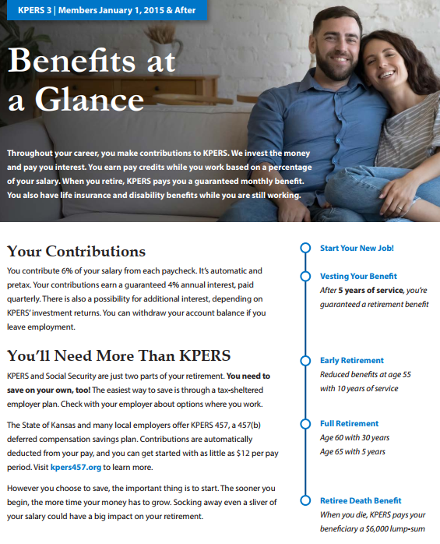

KPERS 3 Benefits at a Glance (Continued)
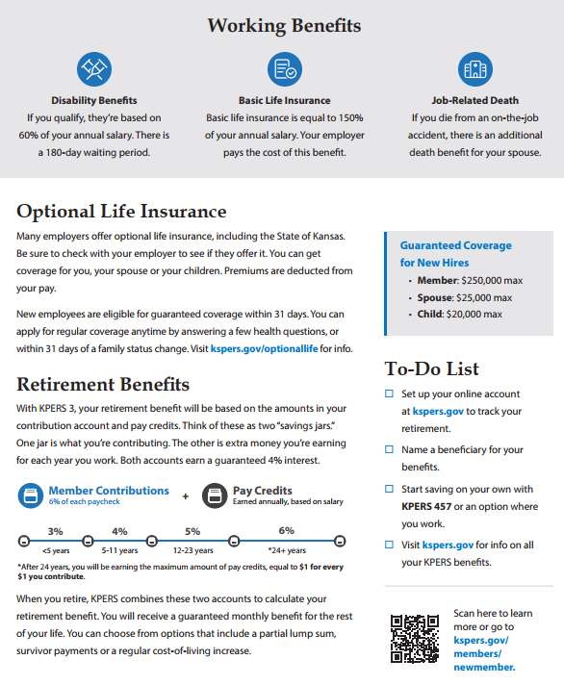

KP&F Benefits at a Glance
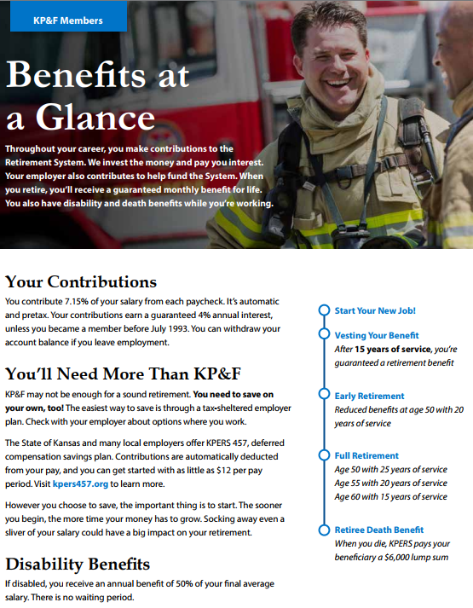

KP&F Benefits at a Glance (Continued)
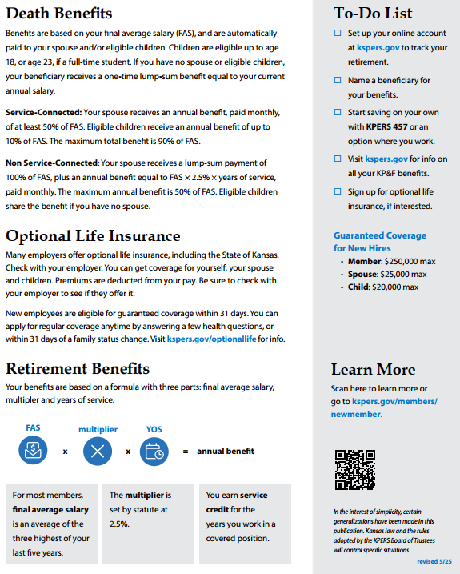

Sedgwick County Additional Benefits
As a benefit eligible employee, you are eligible for paid leave in accordance to Sedgwick County policies.

Vacation Leave
Sedgwick County provides vacation leave accumulation per pay period based on how long you have been employed. For more information on procedures for usage, refer to policy 4.700, Vacation Leave.
40 hour employees:
- 0 to 5 years: 3.69 hours per paycheck
- 6 to 10 years: 4.61 hours per paycheck
- 11 to 15 years: 5.53 hours per paycheck
- 16 to 20 years: 6.46 hours per paycheck
- 21+ years: 7.38 hours per paycheck
Sheriff 42.5 hour employees
- 0 to 5 years: 3.92 hours per paycheck
- 6 to 10 years: 4.90 hours per paycheck
- 11 to 15 years: 5.88 hours per paycheck
- 16 to 20 years: 6.86 hours per paycheck
- 21+ years: 7.84 hours per paycheck
Fire District 40 hour employees
- 0 to 5 years: 3.69 hours per paycheck
- 6 to 10 years: 4.61 hours per paycheck
- 11 to 15 years: 5.53 hours per paycheck
- 16 to 20 years: 6.76 hours per paycheck
- 21+ years: 7.69 hours per paycheck
Fire District 56 hour employees
- 0 to 4 years: 4.61 hours per paycheck
- 5 to 9 years: 5.53 hours per paycheck
- 10 to 14 years: 6.46 hours per paycheck
- 15 to 19 years: 8.30 hours per paycheck
- 20 to 23 years: 9.23 hours per paycheck
- 24+ years: 10.15 hours per paycheck
Emergency Medical 42 hour employees
- 0 to 5 years: 3.87 hours per paycheck
- 6 to 10 years: 4.84 hours per paycheck
- 11 to 15 years: 5.81 hours per paycheck
- 16 to 20 years: 6.78 hours per paycheck
- 21+ years: 7.75 hours per paycheck
Sick Leave
Sedgwick County provides you with sick leave accumulation per pay period. Refer to policy 4.701, Sick Leave.
- 40 hour week: 3.69 hours
- 42 hour week: 3.87 hours
- 42.5 hour week: 3.92 hours
- 56 hour week: 5.53 hours
Paid Parental Leave
Sedgwick County provides you with the ability to bond with a child following birth, adoption, or foster care placement. Refer to policy 4.704, Paid Parental Leave.
Paid Holidays Off
- Labor Day
- Veteran’s Day
- Thanksgiving Day
- Day after Thanksgiving
- Christmas

- New Year’s Day
- Martin Luther King Day
- President’s Day
- Memorial Day
- Juneteenth
- 4th of July
Sedgwick County’s Contribution to Health Care FSA or HSA - Exam Attestation
As an incentive for getting your FREE preventative physical, Sedgwick County will contribute to a Health Care FSA or HSA on January 1, 2027. If you:
- Are enrolled in one of Sedgwick County’s UnitedHealthcare Plans AND
- Have an annual physical exam from October 1, 2026 through September 30, 2027 AND
- Complete the preventative exam attestation on E- line, Employee Self Service (ESS), Benefits, Benefits Attestation Form no later than September 30, 2027.
If your spouse is enrolled in Sedgwick County’s medical insurance and you wish to receive the maximum contribution, you both must have an annual physical exam, and you must complete the online attestation on their behalf. Children exam dates are not required. The one-time annual amount that will be deposited into your account the following January 1 is based off your medical coverage and what you submit on your exam attestation.
Single $75 | Two-Person $150 | Family $220
Gym Membership
Gym membership reimbursement is an incentive program to benefit eligible employees. You can only apply for this during open enrollment. For more information and instructions, go to E-line, Human Resources, Benefits, Benefit Documents, Gym Membership Information.

Helpful Information
Premium:
The amount you pay out of your paycheck to be covered by the plan.
Deductible:
- The annual deductible is the amount of eligible expenses, or the recognized amount when applicable, you must pay each calendar year for covered health services before you are eligible to begin receiving benefits. There are separate In-Network and Out-of-Network annual deductibles for these plans.
- Embedded deductible: If your spouse and/or children are covered by the plan, the individual deductible applies to each covered family member (capped at family amount).

Out-of-Pocket maximum:
The most you will be required to pay out of your pocket for covered health care services in any one calendar year. The out-of-pocket maximum does not include premium payments taken from your paycheck. Plan deductibles and out-of-pocket maximums reset on January 1 each year.
Copay (PPO plans):
Copay is a flat dollar amount and is paid at the time of service or when billed by the provider. Copays count toward the out-of-pocket maximum. Copays do not count towards the annual deductible.
Co-insurance:
A set percentage of the total cost for a covered health care service that you pay after you have paid your deductible. For example, after your deductible is paid, PPO members pay 20% of covered services and the plan pays the remaining 80%.
In-Network providers:
In-Network providers have contracted with UnitedHealthcare and have agreed to provide a discount to UnitedHealthcare plan members. You will pay less out of your pocket when you choose a UnitedHealthcare network provider.
Out-of-Network providers:
Out-of-Network providers, facilities, and pharmacies can charge you the full price for services, which is typically much higher than the In-Network discounted rate. You will pay more out of your pocket when you choose an Out-of-Network provider.
Preventive care:
Healthcare services that help keep you healthy by preventing diseases and other health conditions. The UnitedHealthcare medical plans pay 100% of the cost of preventive care when it is provided by a UnitedHealthcare provider. Some preventive care services that may be covered include: exams, screenings, and vaccinations. Please be aware that you may be billed for non- preventive care services that you receive at a preventive care exam. Learn more about preventive care at www.myuhc.com.




Benefits Enrollment Guide

This Enrollment Guide is for general educational purposes and is based on information provided by the employer, summary plan descriptions, and other sources. In case of discrepancy, plan documents will prevail over information presented in this Guide. Please treat this information as confidential and only share it with your dependents. Contact Human Resources with questions.

